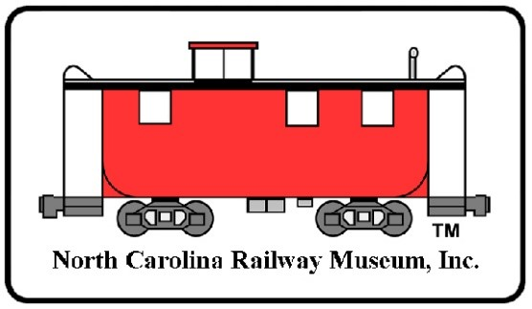
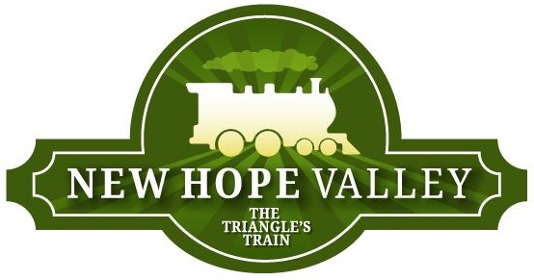
North Carolina Railway Museum
Post Office Box 40
New Hill, NC 27562

APPLICATION FOR MEMBERSHIP
Please print or type

Name: Email:

Home Telephone Mobile: _ Address: _
City: State: Zip:

Your age: Do you have a valid driver's license?

Occupation:

Other historical, preservation, or educational groups you held membership in and location:

List any special interest you have in railroads or railroad history: _______________________

Are you a model railroader? What gauge or scale?

Have you ever been employed by a railroad? What years?

What railroad and where?

Special skil!s, interests, or background info:

Thank you for your interest. We encourage you to become an active member. Please give us the information requested, and add any personal, academic, military, and/or business background you feel pertinent to your joining our group.
APPLICATION PAGE 2

Membership in the NCRM is immediate upon receipt of a properly completed applications and payment of dues. Pursuant to NCRM bylaws, a new member is first classified as a non-voting member. As such, they may not serve on the Board of Directors or vote for Directors at the annual election of Directors or on other issues that may require a membership vote.
After one year of membership, a member may be granted voting rights after showing that they have provided at least (50) fifty hours of volunteer hours of service at the NCRM in the prior twelve (12) months. Any member wishing to become a voting member may self-report hours to the Membership Committee with sufficient detail (dates, hours, and nature of activity) to be verified if necessary.
Please email any questions to info@triangletrain.com

Please mail this Membership Application and your check, payable to NCRM, to:

Membership Chairman Post Box 40
New Hill, NC 27562

- NCRM Individual Dues $20.00 18 years old or older
- NCRM Family Member $5.00/each Must live in the same household
- NCRM Student (Student ID) $15.00 14 to 18 years old
- NCRM donation (optional)
- NCRM Lifetime Member $1000.00

Total: $______________

Membership dues are renewed on January 1st of each year.

All information I have provided is true and correct to the best of my knowledge.

Print Name: ___________________________________________________ Date: ___________________

Signature: _______________________________________________________.

The North Carolina Railway Museum and New Hope Vally Railway are located at 5121 Daisey Street, New Hill (Bonsal), NC 27562. Parking is located at 3900 Bonsal Road, New Hill, NC 27562

www.triangletrain.com
Updated March 29, 2024

