Using VNC on Pi with a 3.5 inch display
When using a 3 ½ inch display on a Rasp pi, there are several issues that need to be addressed:
There is as problem using VNC to transfer files from the Rasp Pi to the pc.
There are additional problems when the FULLSCREEN mode is used.
There is an issue that you also have to deal with when transferring files to the Rasp Pi from a PC. The files can ONLY be sent from the PC to the Desktop folder on the Rasp Pi.
These issues are exhibited in the speedometer program. It consists of a Pi Zero driving a 3 ½ inch display. The graphics for the display were generated useing pygame which is set to FULLSCREEN mode.The program is set to run when power is applied to the Rasp Pi.

Here is the procedure:
Reboot the unit by powering down and then re-starting.
While the autoexec.sh file is launching the python script, stop the execution using Ctrl-c.
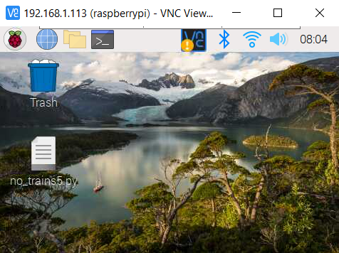 Fig 1
From this display on the tft screen and the VNC screen, if you click on the
The display is will show as Fig 2.
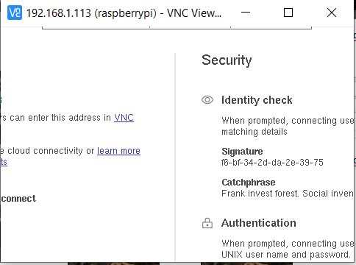 Fig 2
There is no way to exit this without rebooting!
So, do not do this.
The display needed will look like Fig 3.
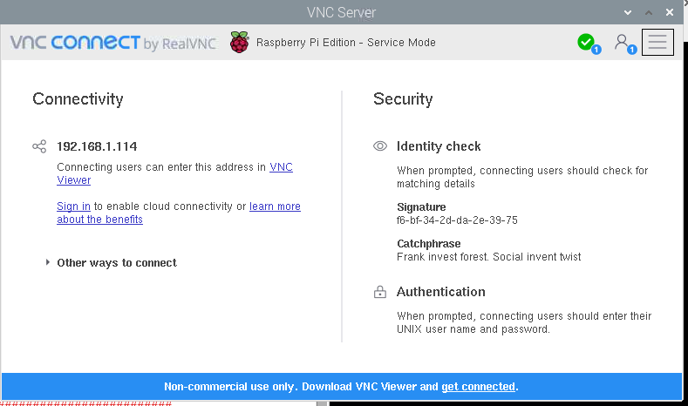 Fig 3

So then you can click on this icon to transfer files an shown in Fig 4.
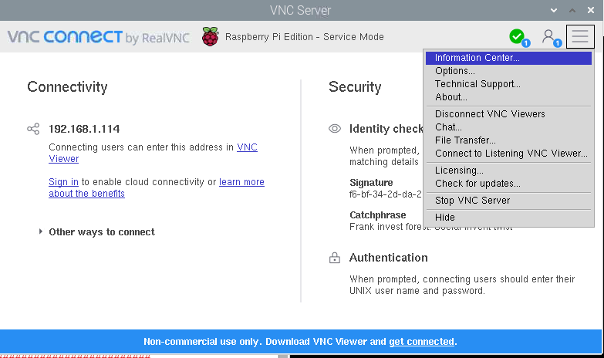 Fig 4

To get to this screen, you have to reboot again sending the display to the hdmi port, even though there is nothing connected to the hdmi port.
Reboot From a terminal window by entering ./hdmi. Then use Ctrl-c, to again, to kill python script that the autoexec.sh has launched. This will stop the FULLSCREEN mode. See Fig 5.
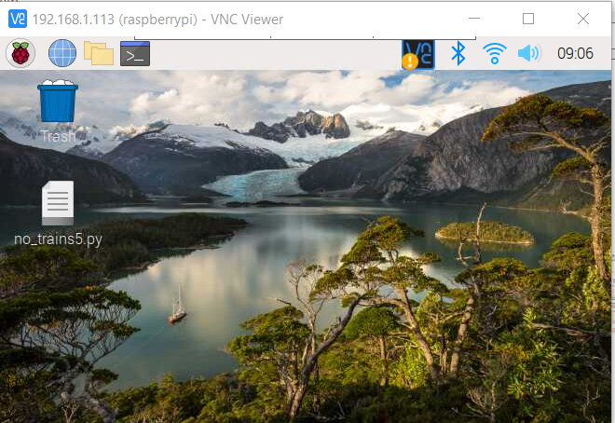 Fig 5 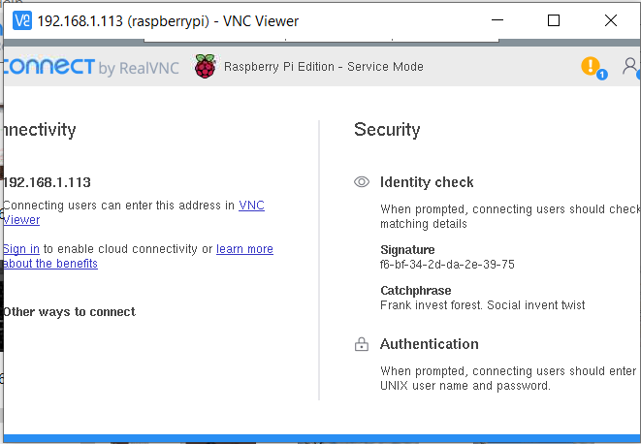 Fig 6
Now when click on , you will see the display Fig 6.
There is an area in Fig 7. that you can click on to move the frame and expose the necessary icon shown in Fig 8.
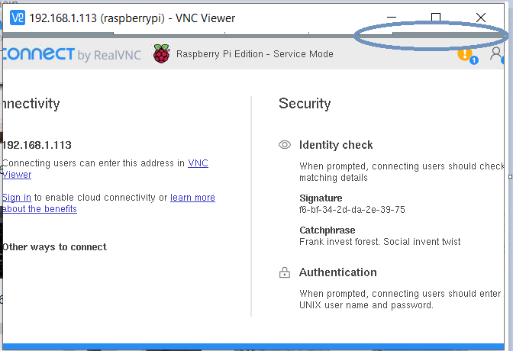 Fig 7 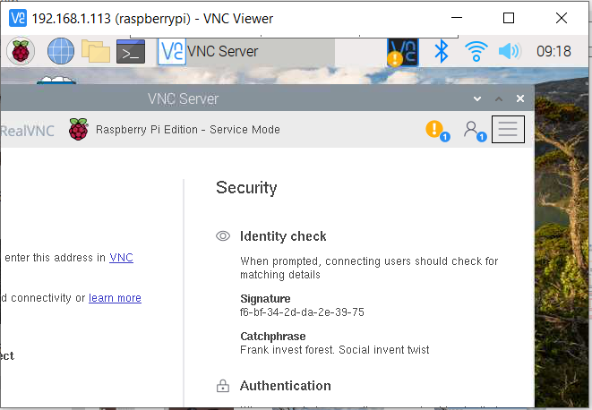 Fig 8

This is what we need to click on to send files from the Rasp Pi to the VNC Viewer on the PC.
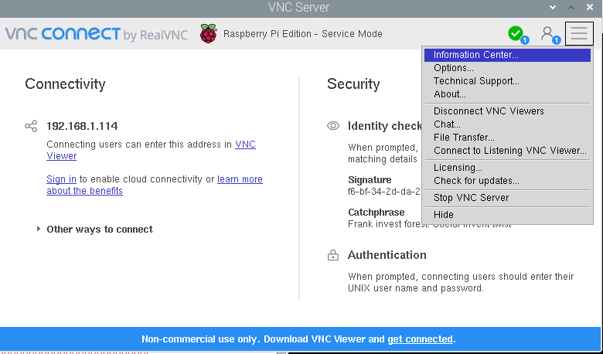 Fig 9.

To return to normal, reboot using ./tft from a terminal window.

