The Train PA system 9/15/26
Latest version of Python gps1.py is gps-411-6-2.py
This file is printed as gps_system_description.pdf.

Overview
The GPS system was designed to play audio clips along the route of the New Hope Valley Railway. The initial motivation was to play sound effects during the Halloween train rides. At a specified latitude, the device would play a specific sound effect.
After the system is powered up, it may take the GPS receiver a couple of minutes to lock on to enough satellites to retrieve valid data. The system then runs autonomously. On startup, the LED indicator will come on after the Linux system loads and the python application has been launched. This takes less than a minute. The indicator will begin to flash when the GPS receiver is locked and is sending valid data to the system. This could take several minutes, depending on the atmospheric conditions.
Operationally, the only thing needed to be done is to connect the battery to the system. The battery is charged on the dispatcher’s desk in the yard office.
After the rides have been completed the battery needs to be returned to the charger.

What is does.
- The system plays audio tracks at several points during the train ride from Bonsal to New Hill and on the return trip from New Hill to Bonsal.
- Plays announcements prior to the departure from Bonsal.
- Plays audio tracks after the train stops in New Hill yard.
- Allows an operator to make live announcements to the passengers
The system runs on a Raspberry Pi-3 mini computer.
The program is written in Python version 2.7. It will not operate on the new versions of the operating systems from the Raspberry Pi organization.
The information for playing the audio tracks is stored in and read from the EXEL file gps_data.csv.
The time information needed to play the pre departure audio files is stored in the EXEL file schedule.csv.
At this time:
The four pre departure announcements are schedule to be played 15, 12, 9 and 6 minutes before the train departs from Bonsal.
The three New Hill audio files will be played 2, 10 and 14 minutes after the train stops at the New Hill yard.
The timings and the audio files can be changed by updating the two EXEL files listed above.

The remainder of the pages below goes into detail on how the system works.

Hardware
Loud speakers. There are four speakers in each of the excursion cars and two speakers in the cabooses.
Raspberry Pi mini computer. Pi-3
GPS Receiver. Globcast BU353
Audio Amplifier
12 volt battery
Cabling and adaptors

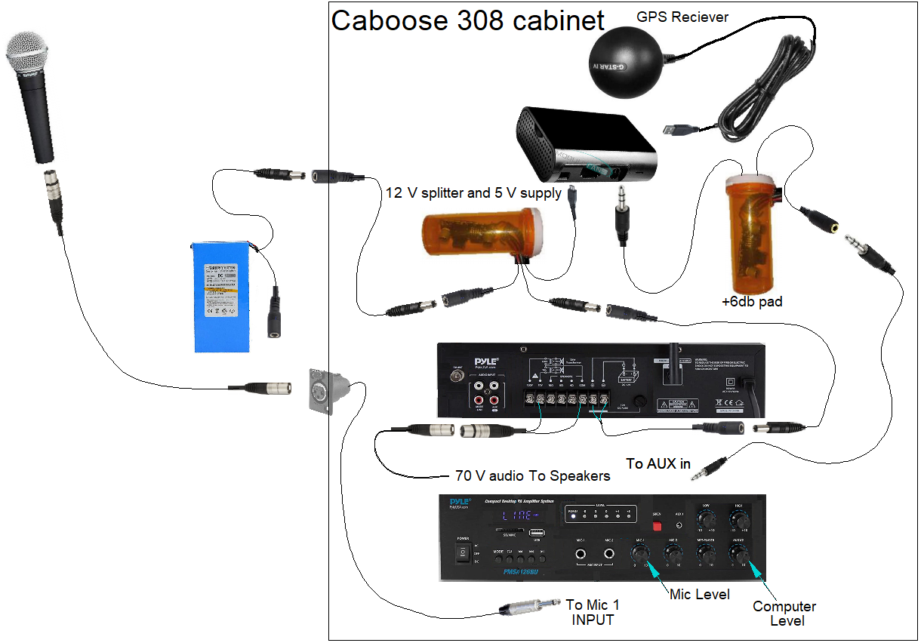

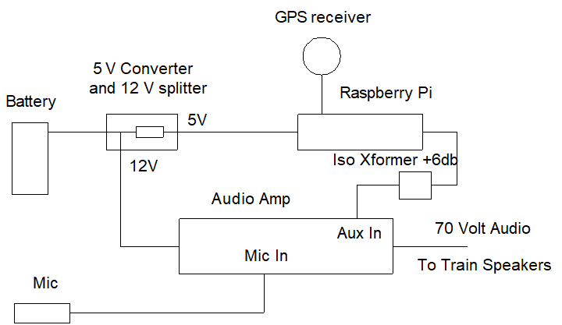
The audio amplifier distributes the audio at 80 volts through an XLR cable in either caboose 308 or car 101. Each speaker has an 80 volt to 8 ohm transformer installed to bring the level down to the proper voice coil level.
This 80 volt audio signal is transferred to the other cars through a ¼ inch Tip-Sleeve audio connecter on each end of the cars. The north end of the car has a female connector and the south end has a male connecter.
When the cars are separated, these connections simply break apart.
The audio output of the Raspberry Pi is too low for the amplifier. The gain was doubled by adding two, 600 ohm isolation transformers wired with the inputs in parallel and the outputs in series.
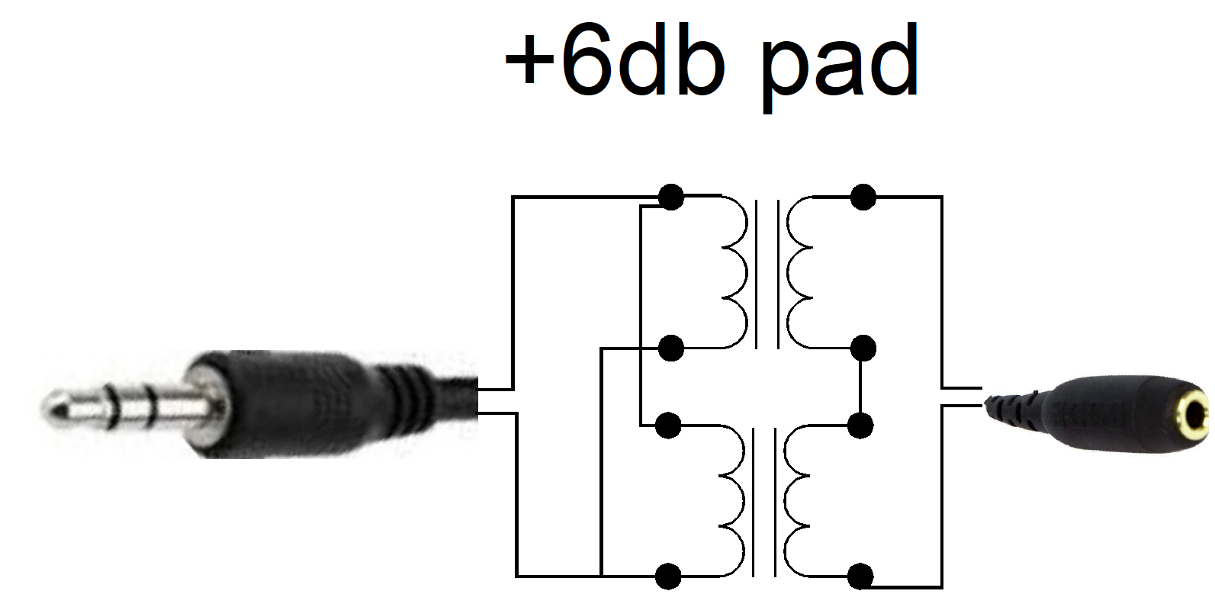
The 12 volt splitter and 5 volt power supply uses an LM2598 Buck switching regulator.
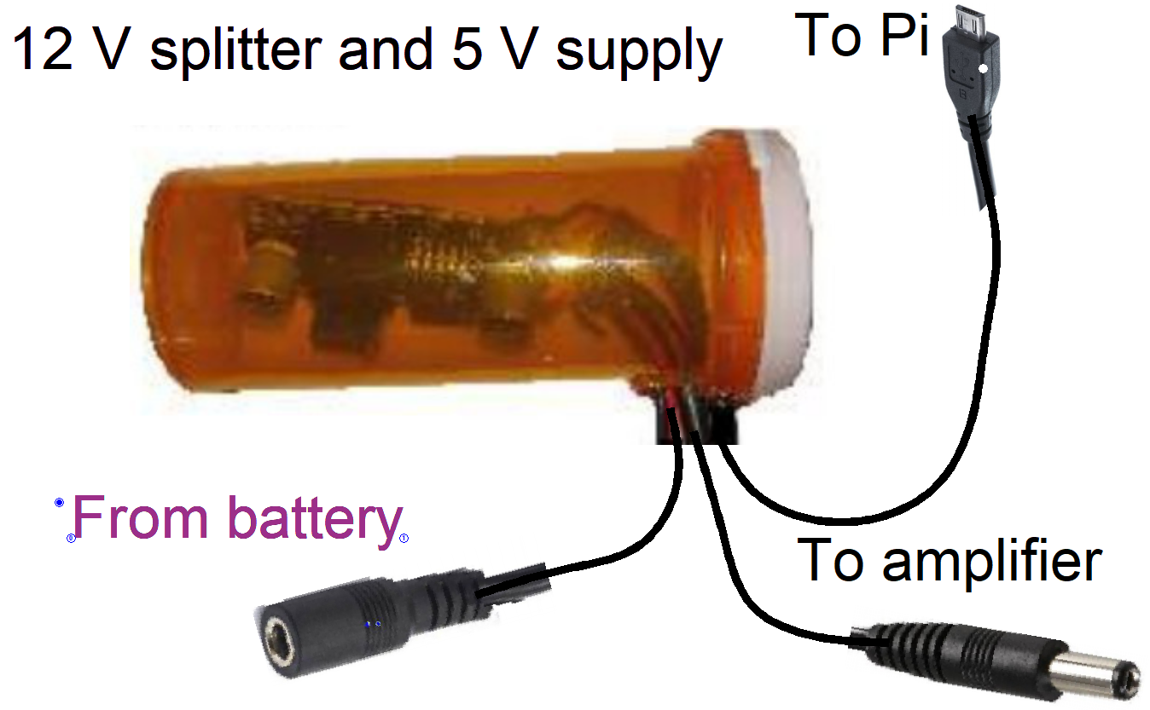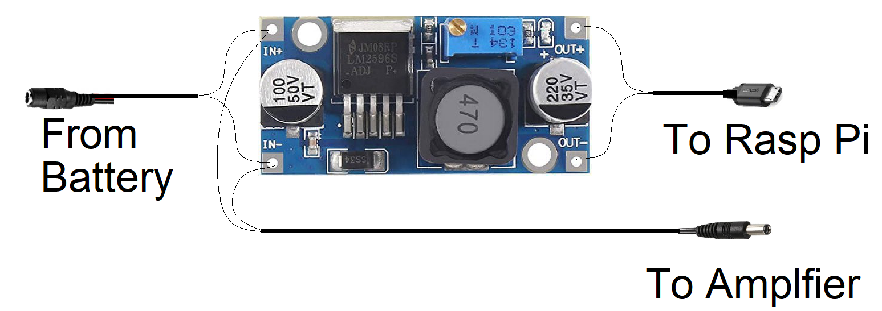

The limiting factor on the system is that as more cars are added a more powerful amplifier is needed along with a more powerful battery.

Operating the system
All the information of when, where and how loud an audio track is played is stored in the EXEL file named gps_data.csv.
To change any of this, open the file and edit the cells that need to be changed.
The files must be in the /home/pi/audio_tracks folder.
There are utility programs in the /home/pi/gps_2017 folder to help with this procedure.
The play_nb.py program will play all of the files in column D.
The play_sb.py program will play all of the files in column F.
The play.py program will play all of the files that are in the /home/pi/audio_tracks folder.
The check_for_audio_files.py program will check to make sure that all the files in the gps_data.csv file exist in the /home/pi/audio_tracks folder. If any are missing it displays a list of the missing files.
These programs can be launched from the /home/pi/gps_2017 folder by entering python and the program name followed by the enter key.
For example, if you want to play all of the clips that will be played when the train is travelling from Bonsal to New Hill
With any of these programs, you can end the playback of the audio track by pressing the q key (QUIT).
You can terminate the program by pressing the Alt-F4 keys.

Notes about data in the gps_data.csv file.
- The file names in columns D and F must match the file names in the /home/pi/audio_files folder
- The file names of the New Hill files must have the length on the play back time, in seconds, as the last four characters in the name.
- For example: his_history_talk_part_2_0108.mp3
The volume levels need to be tested using the utility programs. Start with -200 and increase until there is no distortion.
- The pre-departure times in columns D, E,F and G are in minutes.
- The New Hill delay times in columns D, E, and F in minutes.
- If there are no New Hill files to be played, insert the silence_0002.mp3 files in their place or the system will chash!

Notes about data in the schedule.csv file
- The dates in column B must be in the form of:
8/9/2026, 11/6/2026, 10/1/2026 or 12/10/2026
- The first row should be:

Operating in the linux environment

When the program is launched the screen will look s below.
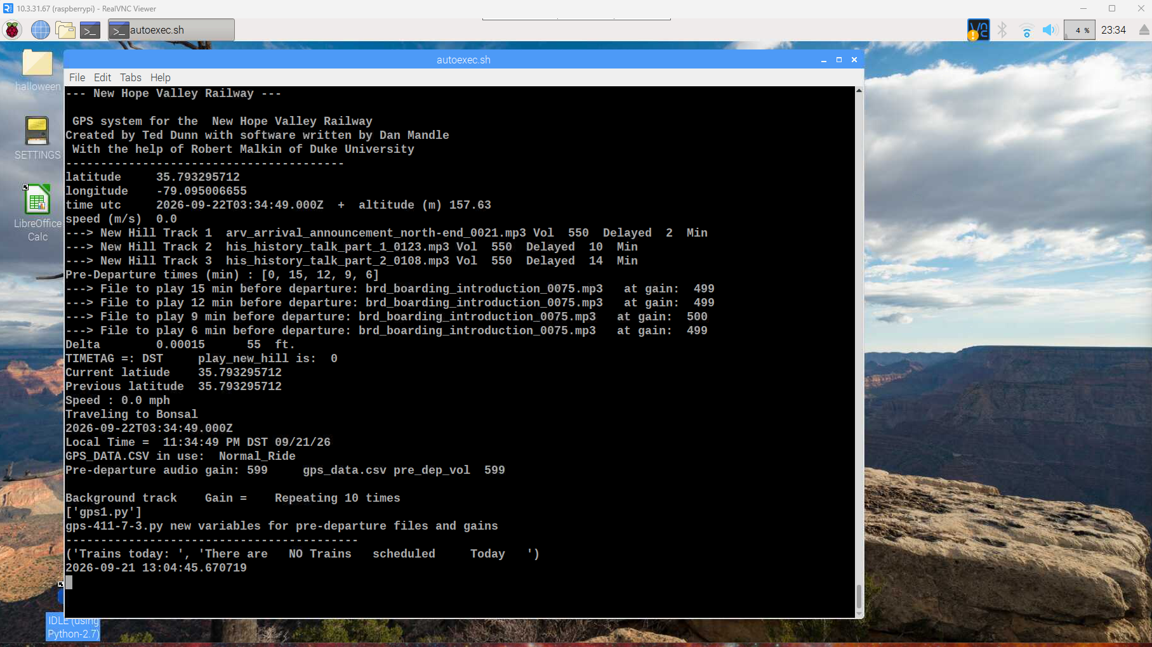
To open another window, click on the  icon in the top left 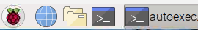

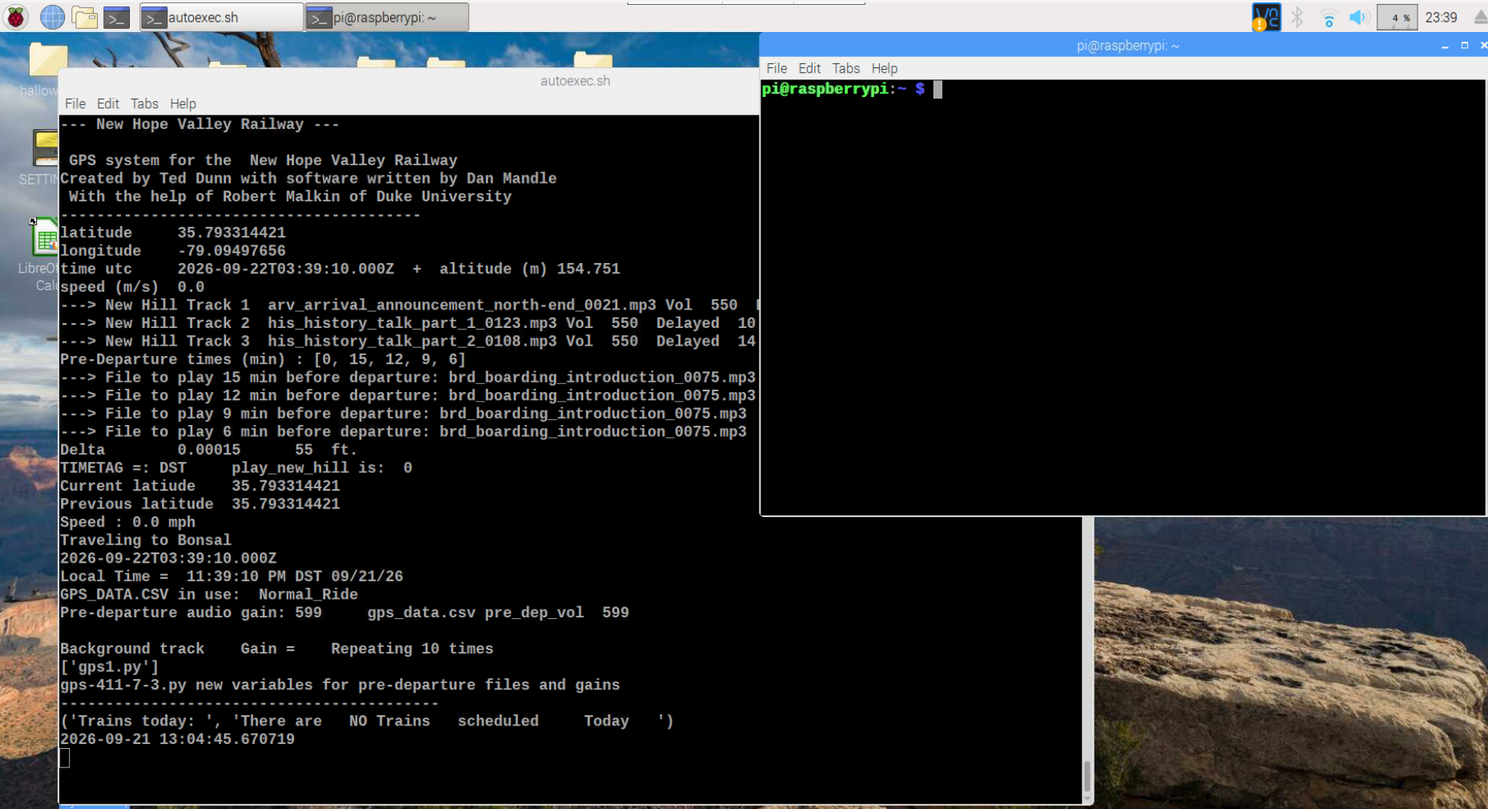

In the new window, you can change to the gps_2017 folder by typing cd gps_2017 followed by the Enter key.
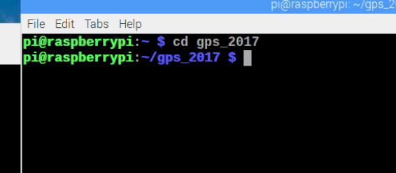

_______________________________________________________________________
Detailed description of the python program gps1.py

The login and password for the Raspberry Pi are pi and raspberry.

The following files need to be in the operational directory: /home/pi/gps_2017

gps1.py (The main operating program)
gps_data.csv (The spreadsheet file containing the data)
load_csv_data.py (Loads the spreadsheet data)
gpssock.sh (see Appendix 8)
schedule.csv This file contains the schedule of the rides for the current year

.desktop (This file is in the /home/pi/.config/autostart folder see Appendix 8)
The following files are needed for version gps-409-xxx.py

The audio files that will be automatically played, must be in the /home/pi/audio_tracks folder.

You need to create a .csv file that contains the latitude, the filename, the volume level. This file can be made with EXEL or Libre calc, which is installed on the Raspberry Pi.
The columns in the spreadsheet are:
A latitude B longitude (not used) C The location name D Audio file to be played going north bound E Audio gain level for northbound clip (usually 0) F Audio file to be played going south bound G Audio gain level for southbound clip (usually 0)

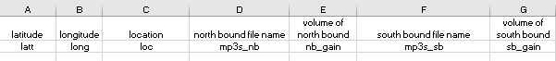
Above shows the columns in the spreadsheet
The functions of each cell and the variable name assigned to it.

Below is the EXEL spreadsheet.

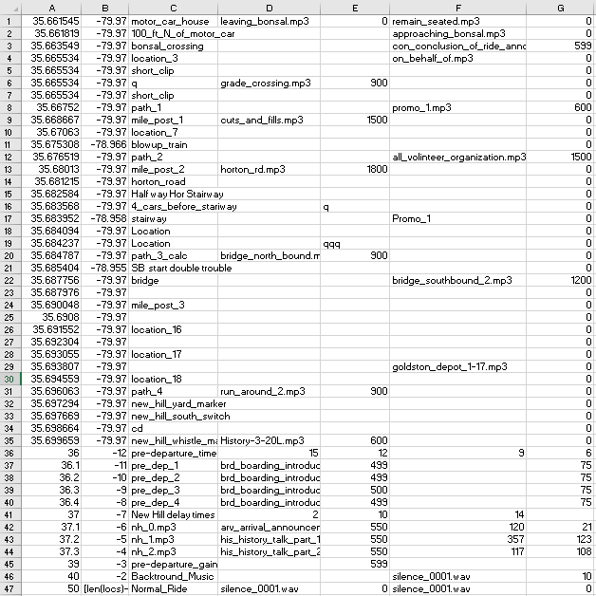The last 12 rows in the spreadsheet contain other information needed by the program. The pre-departure files, volume and time in minutes when they are played. The New Hill files, volume and times delayed from the time the trains stops at New Hill.
The name of this file and the name of the background music file and the number of times it is to be repeated.

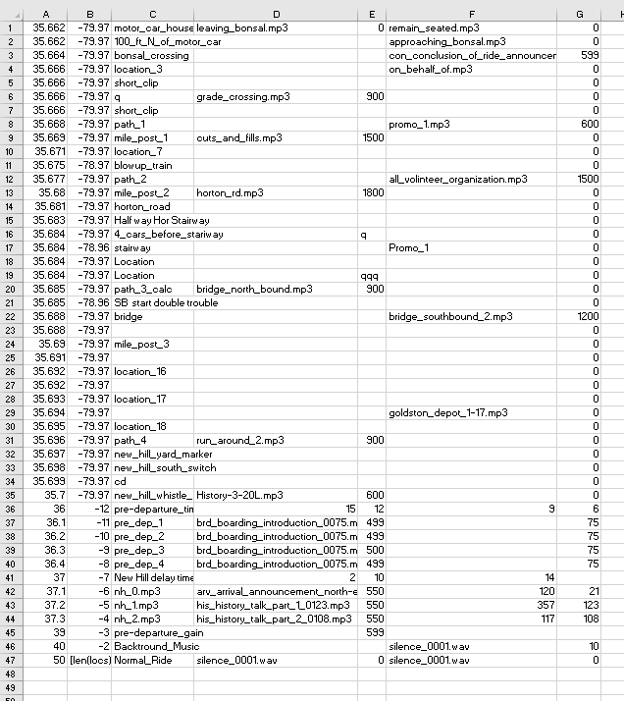

The play announcements before the train departs Bonsal procedure runs from a Python thread. XXXXXXXXXXXX

The variables used in this thread are:

pre_dep_1 The first pre-departure file.
pre_dep_2 The second pre-departure file.
pre_dep_3 The third pre-departure file.
pre_dep_4. The fourth pre-departure file.

The play audio tracks at New Hill yard procedure runs on a python function. XXXXXXXXXXXXX
The variables used in this thread are:

nh_0 The first New Hill file.
nh_1 The second New Hill file.
nh_2 The third New Hill file

Note: the nh_0, the nh_1 and the nh_2 file names MUST contain the name and the playback length.
For example, If the file name is arrival_at_new_hill.py and it is 1 minute and 26 seconds long, (86 seconds) the file name MUST BE:
arrival_at_new_hill.py_ 0086.mp3
The 0086 is needed to determine when the next file is to be played.

The delay times for the New Hill files are 2, 10 and 14 minutes after the train stops in the New Hill yard.

The variables of these delay times in seconds are:
nhsl_0 = 60*int(mp3s_nb[len(locs) -7]) ## Start of first clip The sleep times in seconds
nhsl_1 = 60*int(nb_gain[len(locs) -7]) ## Start of second clip
nhsl_2 = 60*int(mp3s_sb[len(locs) -7]) ## Start of third clip

The variables are:
nhsl_0 = int(mp3s_nb[len(locs)-7])
nhsl_1 = int(nb_gain[len(locs)-7])
nhsl_2 = int(mp3s_sb[len(locs)-7])
The actually delay times are calculated by subtracting the lengths of the audio tracks.
The len_nh_1 is the int(len_nh_1[-4] This strips the

If nh_1 is abcxyz_0232.mp3, the len-nh-1[-8] strips off the last 3 characters.
len_nh_1[-8] is 0232.mp3 and
llen_nh_1 is the interger part of len+nh_1[-4] or 232 seconds

len_nh_1 = nh_1[-8:] is 0232.mp3
lenn_nh_1 =int(len_nh_1[:-4]) is 232
print lenn_nh_1 ## lenght of second clip

The delay of the play times are the sleep_1, sleep_2 and sleep_3 times:
sleep_1 = nhsl_0
sleep_2 = nhsl_1-nhsl_0 - lenn_nh_0 ## Sleep time before second clip
sleep_3 = nhsl_2 -nhsl_1 - lenn_nh_1 ## Sleep time before third clip

Where lenn

The gps_data.csv file in EXEL has seven columns, A through G
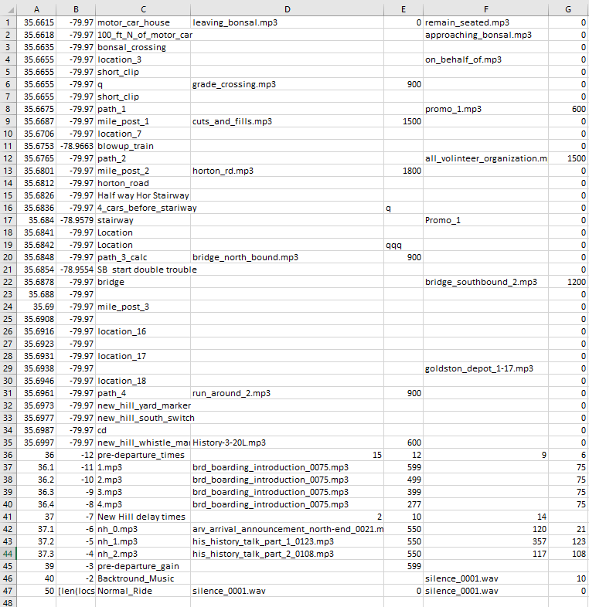
Add at line 1 the following data:
If today’s date is not found in the schedule, it reverts to the first line
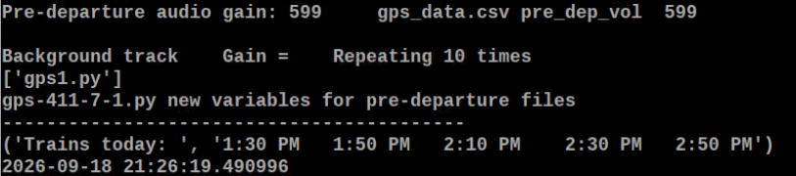

The gps_data.csv file contains the data from the Exel file. It is a comma delaminated text file.

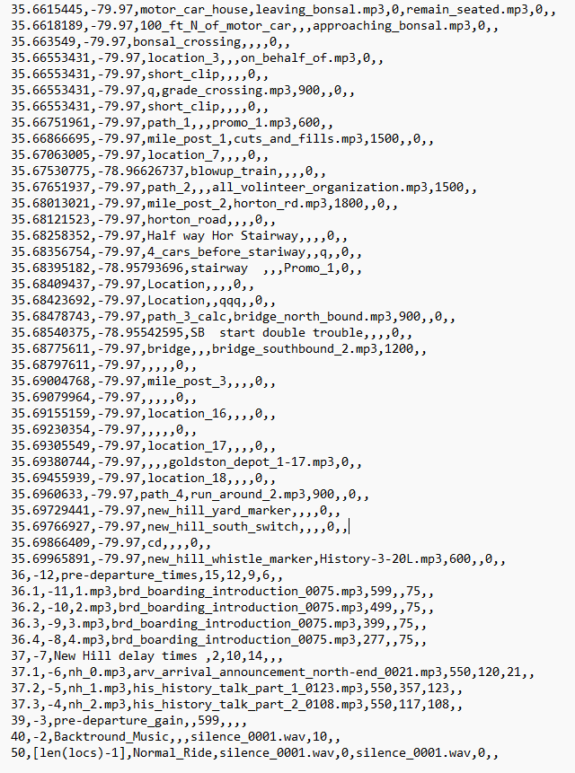

The data is imported by the load_csv.py program with the following variable names:
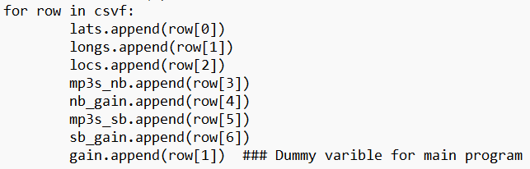

Column A is the latitude.
Column B is the longitude. It is not used
Column C is the location along the right of way
Column D is the name of the audio file to be played going to New Hill.
Column E is the audio level of the file to be played north bound.
Column F is the name of the audio file to be played going to Bonsal.
Column G is the audio level of the file to be played south bound.

The last 12 rows in this file are used to store other data.

When this spreadsheet is imported into python the column are named as variables
Latitude Longitude Location mp3s_nb nb_gain mp3s_sb gain_sb

The last line with the latitude set to 50, in column C shows the name of the .csv file in use. There are several .csv files: Normal_Ride, Halloween_2025, Xmas_2025 etc. When they are used, they are copied to the file named gps_data.csv.
The next to the last row with the latitude 40, in column D, shows the
name of the background audio file to be played and column E is the audio level of the file to be played. Column G is the number of times the file is repeated. In the above example it is left blank and no background audio will be played.

The third from the last row with the latitude of 39, in column E has the audio level of the pre departure files.

- The system will play pre departure announcements 15 minutes, 12 minutes, 9 minutes and 6 minutes before the train is scheduled to depart.
- This information is stored in the python list, at[0,15,12,9,6]. It is retrieved from the gps_data.csv file.

- The file that are played:
  - 15 min prior to scheduled departure is 1.mp3.
  - 12 min prior to scheduled departure is 2.mp3
  - 9 min prior to scheduled departure is 3.mp3
  - 6 min prior to scheduled departure is 4.mp3
At this time, all four of the files are the same audio track. They are retrieved from the gps_data.csv file

The system will play three audio tracks after the train has stopped in New Hill yard. The file will be played 2, 10 and 14 minutes after the train has stopped. The file names are nh_0.mp3, nh_1.mp3 and nh_2.mp3.
The times for the for the delay of the play back of these files and the file names of the tracks that are played are retrieved from the gps_data.csv file.
The audio files must be in the /home/pi/audio_tracks folder.
Note: the nh_0, the nh_1 and the nh_2 file names MUST contain the name and the playback length.
For example, If the file name is arrival_at_new_hill.py and it is 1 minute and 26 seconds long, the file name
MUST BE: arrival_at_new_hill.py_ 0086.py.
The 0086 is needed to determine when the next file is to be played.

Audio File File name Delay value
Variable variable in seconds

nh_0.mp3 arv_arrival_announcement_north-end_0021.mp3 nhsl_0 120
nh_1.mp3 his_history_talk_part_1_0123.mp3 nhsl_1 459
nh_2.mp3 his_history_talk_part_2_0108.mp3 nhsl_2 237

From Calc_NH_Delays.xls
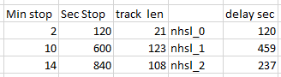

The background music level is set to 12 and is still too high. Try setting it to 6.
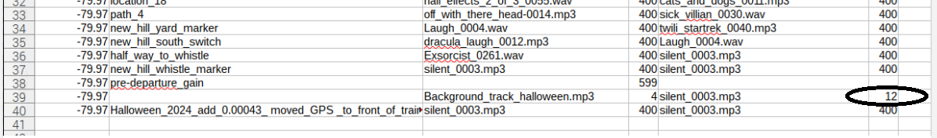

Test Mode:
When developing the software in Fearrington Village, since the latitude is greater than that at New Hill, the system goes in to the play_new_hill_files mode.
To prevent this, the program can be launched with the argument 0 to prevent this from happening: sudo python gps1.py 0.
This sets the play_new_hill variable to 0.
The condition is now false: if play_new_hill == 1 and latt > 35.698 and gpsd.fix.speed*2.236<3:
The variable play_new_hill is initially set to 1. It is set to 0, after all the tracks are played. If the train remains at New Hill the tracks would play again. The variable is reset to 1 when the train passes Horton Rd.
if latt < 35.680 and gps_lock == 1: # At Horton Rd. the variable is reset
play_new_hill = 1

The audio output of the Raspberry Pi is too low for the amplifier. The gain was doubled by adding two 600 ohm isolation transformers wired with the inputs in parallel and the outputs in series.
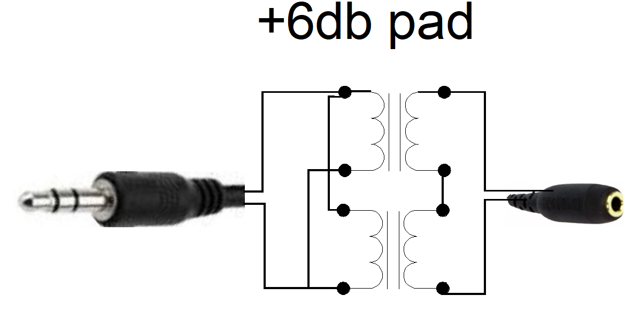

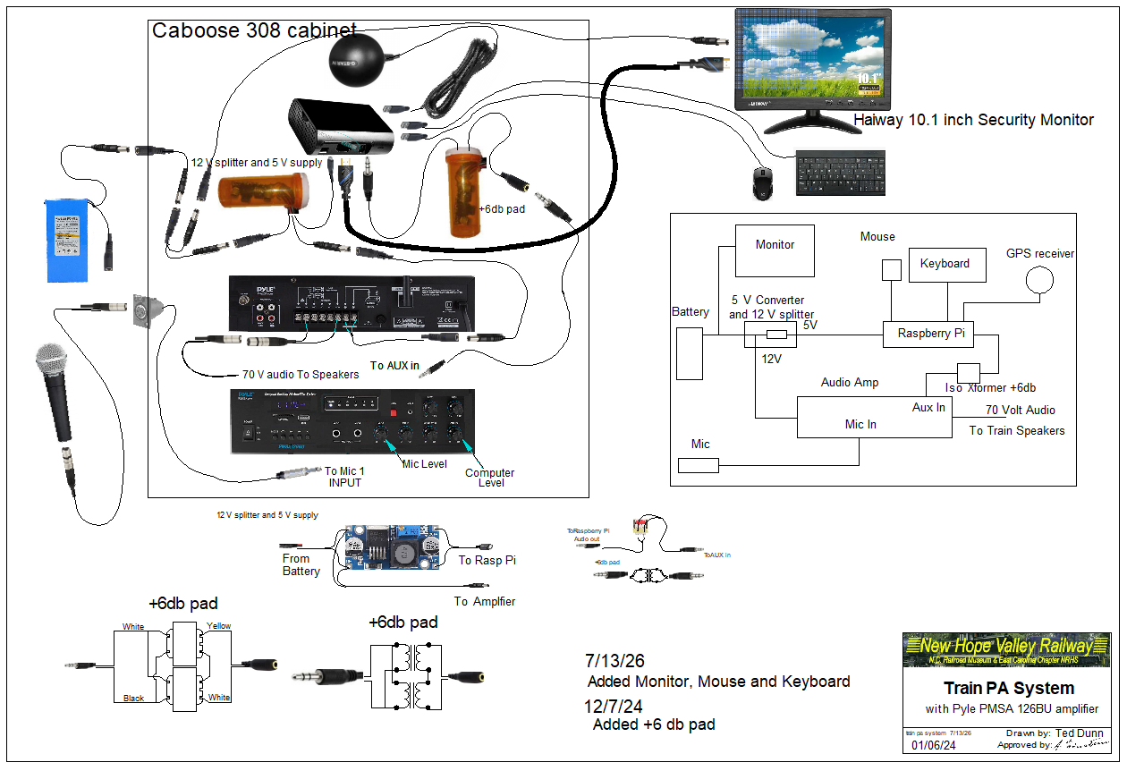
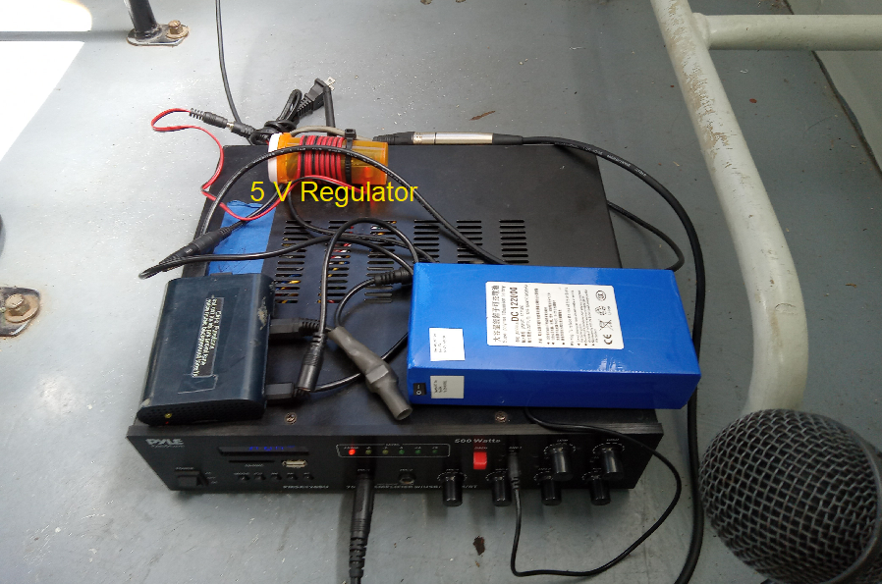

In normal operation the LED will flash approximately once per second. The LED will remain on when the system is capturing and storing positional data. (See ctrl-c functions)
If a background audio track exists, it will begin to play
In 2023, an additional feature was added. The system will now play audio clips before the train leaves the station. The clips will play 15, 10, 5 and 1 minute before the train departs the station. See Appendix 13 for details.

Requirements
The system was designed around a Raspberry Pi computer. The software was written in Python 2.7. To configure and maintain the system, the users need to have a minimum amount of knowledge of Linux, the text-based operating system on the Raspberry Pi and a working knowledge spreadsheets.
The GPS receiver chosen is the Globecast BU353. .
It is a sealed weather proof unit with a USB interface and costs about $35.
See Appendix 8 for details on building the system on the Raspberry Pi.

Executive summary
You need to have a list of the latitudes at which to you want to play a sound track. Use the Ctrl-c feature to capture the data. See below for details.
You need to create a .csv file that contains the latitude, the filename, the volume level (usually 0). This file can be made with EXEL or Libre calc, which is installed on the Raspberry Pi.
The column in the spreadsheet are:
A latitude
B longitude (set to zero)
C The location name
D Audio file to be played going north bound
E Audio gain level for northbound clip (usually 0)
F Audio file to be played going south bound
G Audio gain level for southbound clip (usually 0)

The latitudes can be captured by using the utility in the ctrl-c function.
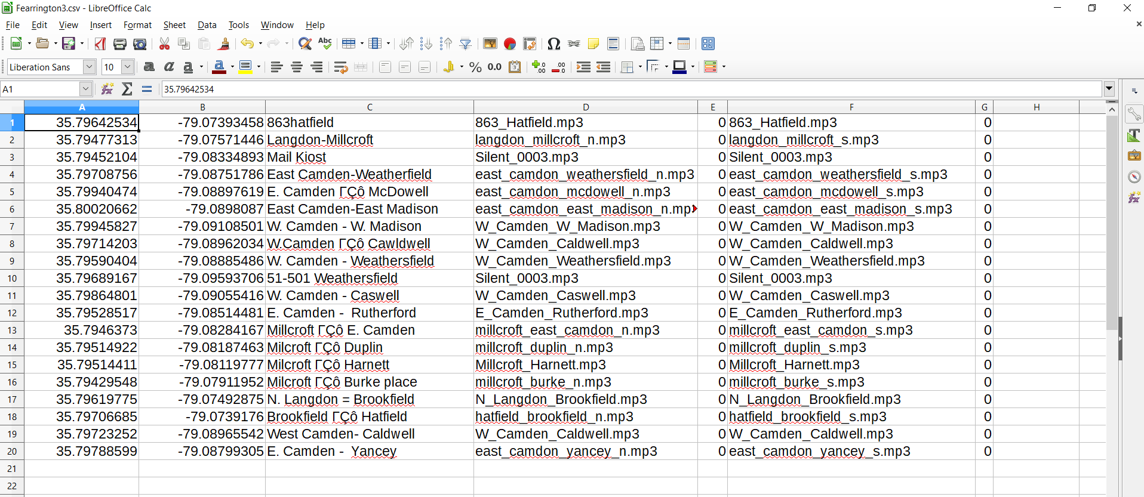
Example of a gps_data.csv file
DO NOT leave line 1 blank!
Save this file with the name: gps_data. Save as type, .csv. This is a Comma delimited file. The file name will be gps_data.csv
This file must be in the /home/pi/gps_2017 directory.
The gps_data.csv file can be edited offline, on a desktop computer, with EXEL. Copy this file to a flash drive with the name USB_DISK.
If this flash drive is in the Raspberry Pi it will upload the gps_data.csv file to the /home/pi/gps_2017 folder on boot up. Disabled.
You need the sound tracks that will be played at each latitude. They can be .mp3 files or .wav files.
Make sure the audio files are in the /home/pi/gps_2017/audio_tracks directory.
There are utilities to check to see if files are missing and to play each file. See Utilities below.
The system creates the following files: logfile.txt, play.txt and datafile.txt .

The last three lines in the gps_data.csv file are unique. The background audio track should be entered in the next to last line. The latitude values of the last three lines are set to 39, 40 and 50.
To play a background audio track, enter the data on the next to the last row. Enter the name of the track in column 4, the gain in column 5 and the number of times the track needs to be repeated in column 7.
To display the name of the csv file, enter the name in column 3 of the last row.
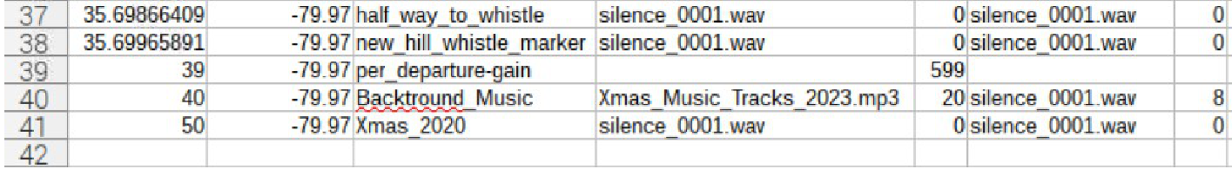
A B C D E F G
1 2 3 4 5 6 7
In the above example, line 39, with the latitude set to 39, the departure audio tracks will play with the volume set to 599 (5.99db).
Line 40, with the latitude set to 40, the background audio track, in column 4, is xmas_Music_Tracks_2023.mp3, with the gain, in column 5 is set to 20, in column 6 and it will be repeated 8 times, as set in column 7.
Line 41, with the latitude set to 50, shows the name for the gps_data.csv file, in column 3.
Note: During normal operations the system does NOT need to have a monitor connected to the Raspberry Pi. When the train is at Bonsal, the operator can connect to the system using the remote software VNC from the computer in the yard office.

The monitor display is:

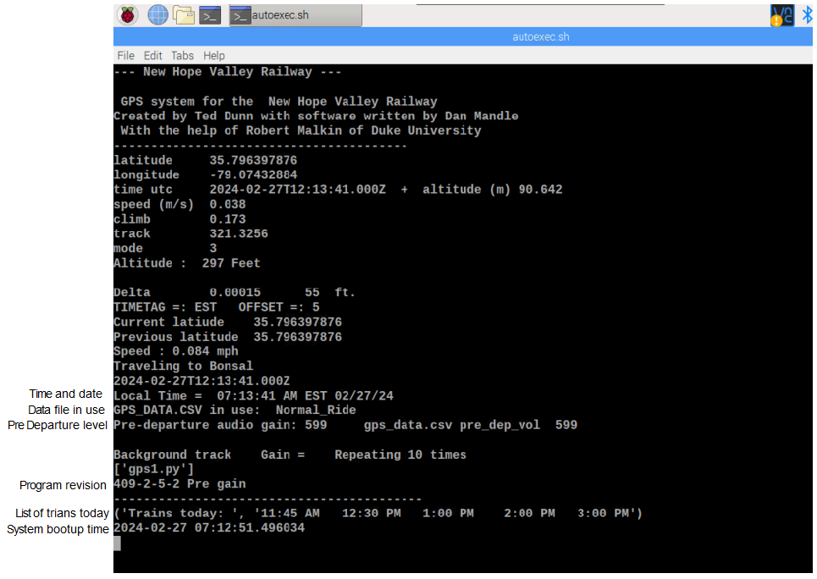
.

gps1.py Program Flow
- Import from libraries
- Set GPIO on Rasp Pi
- Set variables
- Upload and Download to Flash Drive
- Load location data from .CSV file
- Format date and time to EST and 12 Hr
- Create Thread to play audio clip
- Create Thread for background music
- Create function play_new_hill_files()
- Create thread play_clips_before_departing()
- Set Delta to find location
- Run gpssock
- Run the GPS Thread from Dan Mendel
- Save data to logfile.txt
- Check for gps lock
- Find DST data
- Keyboard interrupt ctrl-c from Robert Malkin
- Store Latitude and Longitude to datafile.txt or change time or play audio track

GPS summary gps program flow Search gps1.py with the bold letters
Auto Upload
Read offset and timestamp
function def play_track(name,volume))
load_csv data
def play_clip()
play a background audio clip
play_New_Hill_files
play_clips_before_departing
def confert24(time)
def convert_to_min(strx)
def hms(n)
def conv_min(minutes)
load_schedule
ad = [0,15,10,5,1] Advanced play times
GpsPoller( Set up GPS reader
Main loop
Print screen
Play New Hill audio files
Save Latitiude to logfile.txt
Kill omxplayer
Save played file to logfile.txt
print to screen
Check if gps is locked
ctrl-c functions

Details
All of the files are located in the /home/pi/gps_2017 folder.
To make it faster and easier to copy the program, the following folders were moved from the /home/pi/gps_2017 folder, to the /home/pi folder
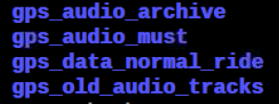
To begin the process, we have to know the latitude of the locations that will play the audio clip. This version does not use the longitude data.
The GPS1 system uses only latitude. This allows the system to play different audio tracks when going northbound and southbound.
Next, you need to know the file names of the audio clips that are to be played.
The file in which this information is assembled is named: gps_data.csv.
This is a spreadsheet file, saved in the .csv format (Comma Separated Values). The Python library has a module to read .csv files. This data, in this .csv file, is read into the system by the program load_csv_data.py.
The gps_data.csv contains seven fields:
Latitude
Longitude
Location
Audio track northbound
Volume level northbound
Audio track southbound
Volume level southbound

Example of a gps_data_csv file
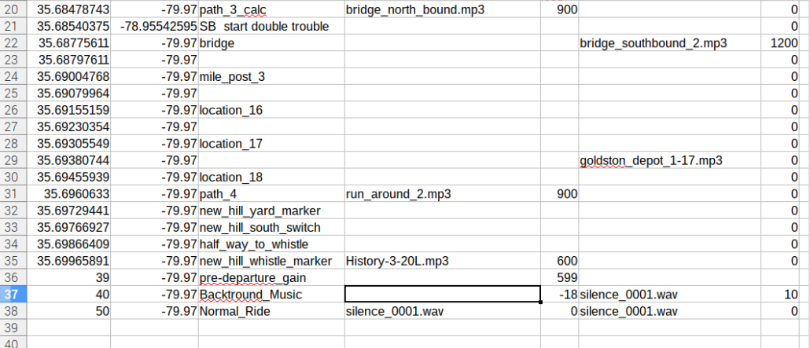
When the csv file is loaded into the system it adds another field the location number. In this case it would be 0 to 13. This can be used to play the audio clips using the play.py utility program.

Not the last few lines of the EXEL file. They contain arbitrary information, not related to the GPS data.

Note: There cannot be an empty row at the top of this spreadsheet. If there is, the load_csv_data.py program will crash.
Hint: You can store different data files by adding a descriptive suffix to the name. For example, save the gps_data.csv as gps_data_halloween_10-20-18.csv. Remember to load all of the audio files listed in the gps_data .csv file into the audio_tracks folder. Use the check_for_audio_files.py utility to insure you have loaded all of the required files.
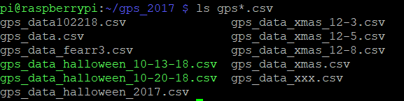
Above is a listing of the data files in the system.

Use the cp command to change the gps_data.csv file. For example to use the gps_data_fearr3.csv file, at the command line in the /home/pi/gps_2017 directory, enter: cp gps_data_fear3.csv gps_data.csv

WARNING: The cp command will overwrite the existing file without warning!

The main program that operates when the train is running is named gps1.py. The program that loads the data from the spreadsheet is, as stated above, load_csv_data.py. This program is run by the import command in the main program.
When the GPS receiver has acquired enough satellites to lock, the date is stored in the text file logfile.txt. This file is then read by the find_dst_import.py routine to determine whether the time standard is DST or EST.
As stated above the audio files are stored in the folder /home/pi/gps_2017/audio_tracks. The names are formatted in the name_length.mp3. The length is four digits and is the duration of the clip in seconds.
For example: There is an audio clip of a “demented man walking” that is 16 seconds in duration. The file name is: demented_man_walking_0016.mp3.
This format was selected so that the audio clips can be easily sorted by length.
When the system is running, and an audio clip is played, the program records the location number, the direction of travel (n or s), date and time, audio file name, location and the file name of the gps program file. This information is stored in the logfile.txt file.
Note: The logfile.txt inserts a blank character at the beginning of the cell. ie (motor_car_house) is stored as ( motor_car_house)
It can easily be imported into a spreadsheet for future use.
Tip: When creating or editing the gps_data.csv file, it is best to copy the audio file names from the audio_tracks directory and paste them into the spreadsheet file. This will reduce typographic errors.
To do this, create a text file of the audio tracks, go to the /home.pi.gps_2017/audio_tracks folder. Use the command: ls > audio_files.txt.(The “>” redirects the “ls” command from the screen to the text file.) Then open the file audio_files.txt, in a spreadsheet to copy and paste the names into the gps_data.csv file.
Similarly, the latitude data from the datafile.txt should be pasted into this spreadsheet file.
Ctrl-c operations
Label:
ctrl-c functions
location, est dst nb, sb, prevol, pre, pre4
voice, music, background, tone1k, tone, nh

The Ctrl-c performs the following functions:
Note: The ctrl-c stops the background audio track. To restart the track enter background.
The original purpose of the Ctrl-c function was to capture the latitude information rather than manually typing it in.
This function has been expanded.
This logging will work without a monitor connected to the Raspberry Pi.
Using the Ctrl-c function.
Press the Ctrl and the c keys. The LED will stop flashing and remain on.
If there is a background audio track running, the LED will continue to flash. Press the Ctrl and the c keys again and the LED will stop flashing and remain on.
Note: The first Ctrl-c will be detected by the mplayer program and will stop playing the background audio track. The next Ctrl-c will be detected by the operating program and will pause the system for the operator to enter the commands.
Operations after ctrl-c is pressed
est Sets system time to eastern standard time
dst Set system time to eastern daylight saving time.
tone Plays a 440 Hz tone for 20 minutes
tone1k Plays a 1000 Hz tone
voice Plays a voice track for 50 minutes
pre Plays the four audio tracks that will play before departure.
pre4 In case the departure is delayed, allows the operator to play the file 4.mp3.
prevol Allows user to change the volume of the four pre- departure audio tracks
nb Plays the north bound tracks
sb Plays the south bound clips
nh Plays the three New Hill audio tracks after the train stops.

To stop playing any these tracks, press the “q” key.

- In order to log the position of a location that you wish to have an audio file play, press the ctrl-c keys. The LED will stay on. Type in the name of this location and press enter. The LED will begin to flash. The data is saved in the file datafile.txt. Note that the datafile records the latitude and the longitude. The longitude is not used in this version.
This file can be opened by a spreadsheet program and the data used to make the gps_data.csv file.

- To play a music track, press the ctrl-c keys, type the word music and press the enter key. To stop playing press the q key.
- To restart the background audio track, press ctrl-c, type the word background and press enter.

Utility files:
check_for_audio_files.py
check_for_audio_filesPC.py
play_nb.py
play_sb.py
playcsv.py
play.py
text_file_2_array.py (This file is created used by the play.py utility.

These files help to manage the audio clips stored in the audio_tracks folder.
The check_for_audio_files.py loads the gps_data.csv file and compares the audio file names found, with the files in the audio_tracks directory. If it cannot find a file, it lists the file in the missing_audio.txt file. If the flash drive is mounted on the system, the missing_audio.txt file is copied to it.
To use these utility programs:
Open a new window
At the command line, change to the gps_2017 directory by typing:
cd gps_2017 (change directory)
At the command line enter: python {name of utility}
For example:
At the command line enter: python check_for_audio_files.py

The check_for_audio_filesPC.py runs on a PC system.

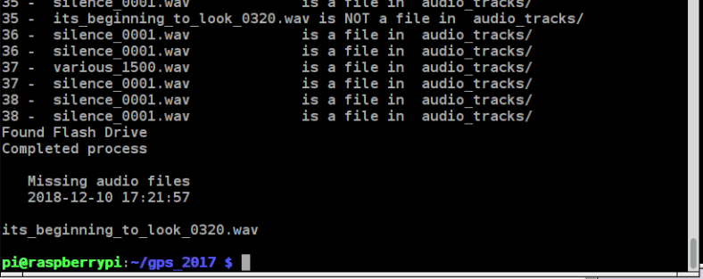
This is what the screen looks like if a file is missing.

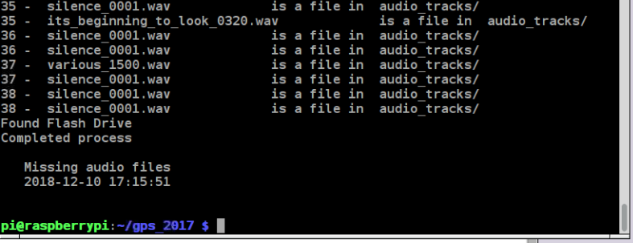
This is what the screen looks like if there are no missing audio files.

The utility files play_ nb.py and the play_ sb.py will play all of the audio tracks that will be played on the route based on the contents of the load_csv_data.csv file. To play them in the proper sequence, the gps_data.csv file should be sorted by the latitude column.
To use these utility programs:
Open a new window
At the command line, change to the gps_2017 directory by typing:
cd gps_2017 (change directory)
At the command line enter: python play_ nb.py or
python play_ sb.py
Tip: When using these utility programs, pressing the q key will stop the audio clip that is playing and start the next clip. See all of the omxplayer commands in appendix 1.

ca

This utility program will play any clip in the audio_tracks folder at any volume level

At the command line, in the gps_2017 folder type:
python play.py
The screen will display all of the audio files in the audio_tracks folder and assign an index number to each file. It will then prompt you to enter the file number.
It will then prompt you to enter a gain level. This can be any number between -2500 and +1000. To double the gain of the audio clip enter 600. This will increase the volume level by 6 db (decibels). Similarly to reduce the level by half, enter -600. This will decrease the volume level by -6 db .
The program will then play the audio file with the gain level that was entered.
If the gain was OK, you can save the information for future reference to the file saved.txt by entering the y key when prompted.

If you wish to replay the audio clip, launch the program again and when prompted to enter a file name, hit the Enter key. If you wish to change the gain, at the prompt, enter a new gain number and hit Enter key. If you wish to play the file at the same level just hit the ENTER key and it will play it at the previous gain level.
The previous file name and previous gain level are stored in the play_last.txt file.

Note that it is more convenient to have subfolders which contain the audio files for specific events. For example, a Halloween effects folder and Bonsal test files folder. When using these audio files, copy them from the subfolder to the audio_tracks folder.

playcsv.py

This utility program will play any clip in the gps_data.csv file at any volume level.

At the command line, in the gps_2017 folder type: python playcsv.py

Below shows the screen when the program is run. Number 32 was entered, the jingle_bell_rock_0158.wav file. The gain entered was 100 and the audio clip was played. The clip playback can be cancelled by pressing the q key (for quit).
Note that the screen shows the ‘Last Played: “ file was frosty_0210.wav. If you wish to replay that file, just hit the Enter key. Then enter the desired gain.
You can save the data to the saved.txt file by entering Y or y.

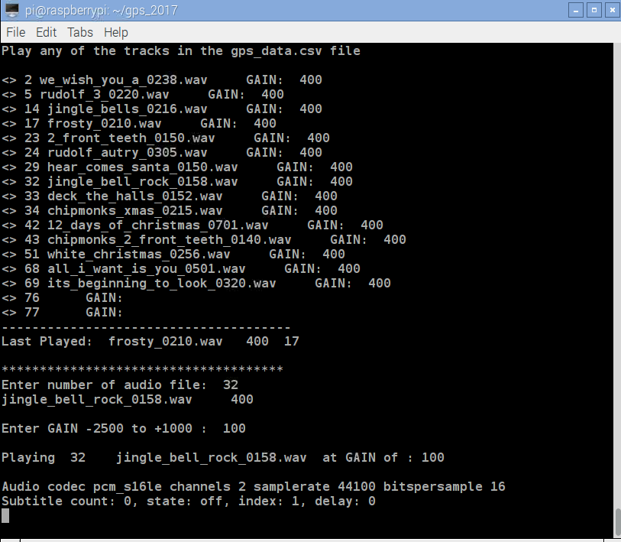

You can save the data to the saved.txt file by selecting Y.
Below are the last few lines in the saved.txt file.

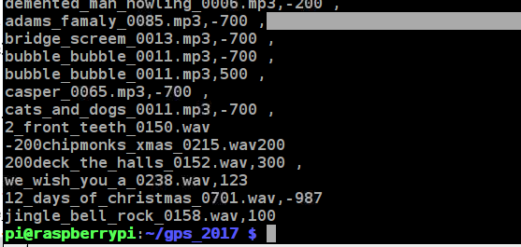n

In summary:
The following files need to be in the operational directory: (/home/pi/gps_2017)

gps1.py (The main operating program)
gps_data.csv (The spreadsheet file containing the data)
load_csv_data.py (Loads the spreadsheet data)
gpssock.sh (see Appendix 8)
play_ nb.py (Utility to play audio tracks)
play_ sb.py (Utility to play audio tracks)
play.py (Utility to play and change the audio tracks)
text_file_2_array.py (This file is used by the play.py file.)
playcsv.py (Utility to play only files in gps_data.csv)
check_for_audio_files.py
.desktop (This file is in the /home/pi/.config/autostart folder see Appendix 8)
The following files are needed for version gps-409-xxx.py
schedule.csv This file contains the schedule of the rides for the current year
1.mp3 In the audio_files folder.
2.mp3
3.mp3
4.mp3
tone.mp3

The following files will be created:
logfile.txt (logs whenever an audio clip is played)
datafile.txt (store latitude data captured by ctrl-c)
bootlog.txt (Stores data from the last startup)
missing_audio.txt (Created by the check_for_audio_files.py) file.)
saved.txt (Stores file names and gain of all the audio files played)
play_last.txt (Stores data of the last audio files played by play.py)
play_last_csv.txt (Stores data of the last audio files played by (playcsv.py)

Other files and folders 11/02/23
The audio_archive folder contains all of the audio files that have been uses. The audio_archive folder has been moved out of the …gps_2017 folder to the /home/pi folder to make it faster to copy the gps_2017 folder over the network.
A new folder was created: /home/pi/gps_data_normal_ride.
This folder was added to make it easier to change the GPS system, when changing from normal rides to special event rides.
This folder contains the gps_data.csv file and the corresponding audio files required.
The gps_data.csv file should be copied to the gps_2017 folder.
The audio files should be copied to the gps_2017/audio_tracks folder.
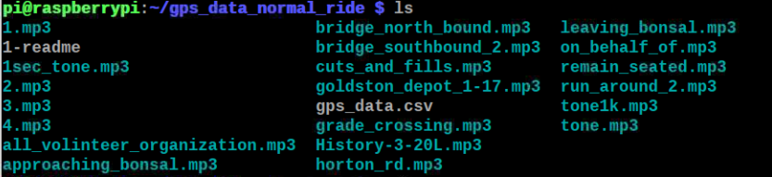

The sound effects tracks are played using omxplayer. This is part of the NOOB’s installation.
The background music track is played using mplayer.
The media player mplayer must be installed. It is used to play the background music track.
At the command prompt, enter: sudo apt-get install mplayer.
It may take 10 minutes to load.
The mplayer does not paly audio on the Pi-4.

A Flash drive is optional. It needs to have the name: USB_DISK.
It can be used to configure the system “offline”, by adding files to this drive from another PC and to download and analyze the data saved by the system offline without removing the system from operation.
When the system boots up it will:
- Download the files logfile.txt , datafile.txt and gps_data.csv as gps_data_downloaded.csv.
- If gps_data.csv file is on the FD, it is uploaded to the system’s SD card.
- If the file est_dst.txt is on the FD it will change the time standard to Eastern Standard or Daylight Savings time.
The Flash Drive should have two text files est.txt and dst.txt.
For Eastern Standard time the text file contains: 5EST
For Daylight Savings time the text file contains: 4DST
To change the time standard, copy either file to a new file est_dst.txt.

With the flash drive plugged into the system, the files will automatically be uploaded when the system is rebooted.

As stated above, the audio clips used are stored in a separate folder.
In the /home/pi/gps_2017 directory, create a folder audio_tracks
Place the audio files, in .mp3 or .wav format, into the folder: /home/pi/gps_2017/audio_tracks.
Tip: WAV files can be edited using Audacity, a free audio editing program. MP3 files were used in a previous version of the system that used an mp3 player and cannot be edited.
Tip: Files can be captured using Sound Trap, a free streaming audio recorder.

AUTOSAVE to Flash Drive Introduced in version gps-404.py.
A feature was added that automatically copies the logfile.txt file to a flash drive, if it is plugged into a USB port. The flash drive must have the name USB_DISK. This is accomplished when the speed is less than 3 MPH and the latitude has changed from the last time the file was saved.
If the system is stationary, the logfile will only be saved once.

############## Autosave logfile to flash drive named USB_DISK
if (gpsd.fix.speed*2.236<3 and abs(lattsaved -latt) > 2*delta):
print ' Copying logfile to flashdrive'
copyfile('/home/pi/gps_2017/logfile.txt','/media/pi/USB_DISK/logfile.txt')
lattsaved =latt
print lattsaved

##### Autosave logfile to flash drive named USB_DISK
if (gpsd.fix.speed*2.236<3 and abs(lattsaved -latt) > 2*delta)and os.path.isdir('/media/pi/USB_DISK'):
print ' Copying logfile to flashdrive'
copyfile('/home/pi/gps_2017/logfile.txt','/media/pi/USB_DISK/logfile.txt')
lattsaved =latt
print lattsaved

The routine if clause checks the speed, the change in latitude and whether the Flash Drive is mounted. If it finds the drive it copies the logfile to it. If there is no drive in the USB port, the programs continue to run without incident.
This allows the GPS System to continue to operate while the logfile data is analyze in another system.
UPLOAD GPS DATA version 404-2
The problem: To change the GPS data, the system must be setup with a monitor, mouse and keyboard and the gps_data.csv file must be modified.
The solution: Install a flash drive (named USB_DISK) with the new GPS data in the file gps_data.csv.
Reboot the system.
The system does the following:
- Checks if there is a flash drive named USB_DISK in the system.
- Saves a copy of the logfile.txt on the flash drive.
- Saves a copy of the gps1.py on the flash drive.
- Checks if there is a gps_data.csv file is on the flash drive
- Checks if there is a file est_dst.txt on the flash drive.
- Checks if there is a datafile.txt on the system drive.
- Saves a copy of the results to the file bootlog.txt to both the /home/pi/gps_2017 directory and the flash drive.

rm_logfile.txt
You can delete the logfile.txt file from the system drive (the SD Card) automatically when the system boots up by placing a file called rm_logfile.txt on the flash drive. Remember that the logfile.txt is always saved to the flash drive and if the rm_logfile.txt is on the flash drive it will be erased from the SD Card. Note that the rm_logfile.txt is also erased from the flash drive. It must be placed on the flash drive each time you want to erase the logfile.txt. It does not matter what is in the rm_logfile.txt. As long as this file is present on the flash drive, it will erase the logfile.txt on the system drive (the SD card) and then erase the rm_logfile.txt from the flash drive. Just copy any file to rm_logfile.txt.
For example: cp est.txt rm_logfile.txt

Remember that the audio files listed in the gps_data.csv file must be present in the /home/pi/gps_2017/audio_tracks directory.
Use the utility check_for_audio_files.py to verify that the audio clips are correct.
Note: There is a 4 second delay during boot up. Otherwise the system will not see the flash drive!
There is another 10 second delay to allow the operator to read the display output of the script if a monitor is connected to the system.

Tip:
Aside from the est.txt and the dst.txt files on the flash drive, copy the versions of the gps_data.csv files with descriptions on the flash drive. This will make it easier to change the gps_data.csv file on another computer.

Other Stuff
Text to speech software has improved dramatically in the last few years. These online programs will accept a text file and convert the text to an audio file. As of 6/9/23, the website:
https://speechify.com/text-to-speech-online/?landing_url=https%3A%2F%2Fspeechify.com%2Ftext-to-speech-online%2F
is what I have been using.
You will notice that in the program, when ever files are accessed or loaded, the absolute path is used ie: file = open('/home/pi/gps_2017/logfile.txt','a').
This was done because of the way the program was launch on powering up the Raspberry Pi using the autoexec.sh script called by the .desktop file in the autostart folder. See Appendix 8, section 9 for more details. If the program was run from the gps_2017 directory, relative paths could be used.
The software needed to read the GPS receiver can be installed from this link:
http://www.danmandle.com/blog/getting-gpsd-to-work-with-python/

There is another procedure that I used to install the GPS receiver from this link:
http://www.instantsupportsite.com/self-help/raspberry-pi/raspberry-globalsat-353s4-install/

This worked when the initial installation was performed on both the 2 and the 2B systems.
However, I tried it recently and found that the /lib/udev/gpsd.hotplug file does not exist and I was unable to read the data from the receiver.

The SD chip used on the Raspberry Pi 2B works on the 3B and the Pi Zero.

If a Raspberry Pi 2B or 3B are used the time and date are correct
If a Raspberry Pi 2 is used the time will be correct, but the date is off by 7168 days!

Once this is installed, the system is functional and can be used.

Notes:

The system can play a different audio track at a location depending in the direction of the train. There are times that you may not want to play a track in one direction. In the folder audio_clips there is a file named silent.mp3 for this purpose.
The system to date only monitors the latitude data. When the train proceeds past Bonsal Crossing Rd., the train’ heading is approximately north-east.

In warm weather, the announcer usually sits in north end of car 101. In cold weather he sits in the caboose. He offset between these two positions is .7 times the distance between these two points.
Or 150 ft. Times .7 or 105 ft. This translates into .00027degrees.

The GPS receiver chosen is the Globecast BU353.
.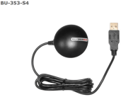
It is a sealed weather proof unit with a USB interface and costs about $35.
http://www.instantsupportsite.com/self-help/raspberry-pi/raspberry-globalsat-353s4-install/

Note: This installation worked fine when it was originally used in August 2016.
It is not working at this time.
There are also problems with it on the RaspPi-2B. The RaspPi-2 works fine. See anomalies section for details and solution

The program uses python code developed by Dan Mandle. Here is the link:
http://www.danmandle.com/blog/getting-gpsd-to-work-with-python/
The first few lines of for gps1.py code are shown below:
import argv was used to display the file name of the program automatically
The remainder of the imports were from Dan Mendle.

A special thank you to Robert Malkin of Duke University. He is a volunteer at the Visual World Investigate Lab at the Museum of Natural Sciences in Raleigh, NC. He was very helpful in making the ctrl-c routine work. I could not have done this without him.
System Setup
Hardware:
Raspberry Pi 3 with LED connected to ______
Globcast BU353 GPS receiver
Power supply
USB keyboard
Software:
Pre-configure 16 gig SD chip.

Adding the LED
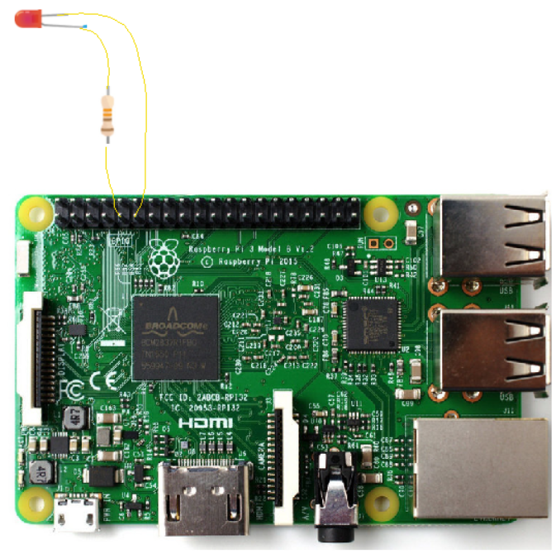

GPS description - Other details
Auto Upload
Delays the running of the shell script for 3 seconds.
Otherwise the script does not run! A delay of 1 second does not work
A delay of 2 seconds works. Set the delay to 3 seconds.
When the cp_stuff.sh is copie, it sometimes must be made executable
readtime module
The est_dst.txt file contains one line.
For Eastern Standard time it is 5EST
For Daylight Savings time it is 4DST
The file is read with the "with open(......"
The line is converted to a string with y= str(content)
The offset is converted to an integer from y
The timetag is stripped froom the string y
The gps_data.csv file is imported by
from load_csv_data import command
The file is load_csv_data.py
The EDST(utc-gpsd) function converts the time to every day format.
The format of utc-gpsd is : 2018-04-08T22:43:10.000Z
Which outputs DST = 6:42:10 PM 04/8/18
There is an issue with this function during the last day of the month
For the last day of month, before midnight, the day is set to zero
ie 04/0/18. It should be 03/31/18

Appendix 1 OMXPLAYER keyboard commands (https://elinux.org/Omxplayer)
Key Action

1 decrease speed
2 increase speed
< rewind
> fast forward
z show info
j previous audio stream
k next audio stream
i previous chapter
o next chapter
n previous subtitle stream
m next subtitle stream
s toggle subtitles
w show subtitles
x hide subtitles
d decrease subtitle delay (- 250 ms)
f increase subtitle delay (+ 250 ms)
q exit omxplayer
p / space pause/resume
- decrease volume
+ / = increase volume
left arrow seek -30 seconds
right arrow seek +30 seconds
down arrow seek -600 seconds
up arrow seek +600 seconds

OMXPLAYER documentation: https://www.raspberrypi.org/documentation/raspbian/applications/omxplayer.md

To adjust the volume use the command: omxplayer --vol ‘xxxx’ ‘filename’
Where xxx is in millibels. For a 6 db change xxxx= 600.
A +6 decibel (db) change doubles the audio level. A -6 db change halfs the audio level.
http://coretechgroup.com/dbm_calculator/
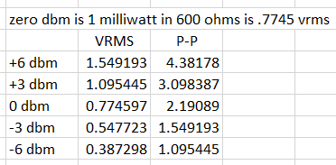

Appendix 2 USB Boot routine
When a USB flash drive is installed in a Raspberry Pi, it mounts in the /media/pi folder.
Opens bootlog.txt file to write.
Checks for the presence of the USB Flash Drive with the name USB_DISK.
If True:
Copies logfile.txt, gps1.py and gps_data.csv as gps_data_downloaded to Flash Drive.

Note: This will overwrite any existing files on the USB Flash Drive.
Checks if rm_logfile.txt is on the Flash Drive.
If True:
Deletes the logfile.txt from the system SD card.
Deletes the rm_logfile.txt from the Flash Drive.

Checks if gps_data.csv is on Flash Drive.
If True:
Saves the gps_data.csv file as old_gps_data.csv on SD card.
Saves the gps_data.csv file as old_gps_data.csv on FD.
Copies gps_data.csv file from Flash Drive to the system SD card.
Deletes the gps_data.csv file from the Flash Drive.
Checks if the est_dst.txt file in on the Flash Drive.
If True:
Copy est_dst.txt to system SD card
Delete est_dst.txt file from Flash Drive.
Checks if there is a datafile.txt file on the system SD card.
If True:
Copies datafile.txt to the Flash Drive.
Checks if there is a rm_datafile.txt on the Flash Drive.
If True:
Deletes the datafile.txt from the system SD card
Deletes the rm_datafile.txt from the Flash Drive.
Closes bootlog.txt file
Copies bootlog.txt file to Flash Drive.

Appendix 3 Pi-Zero analog audio output

How Other Pi's Create Audio

https://learn.adafruit.com/introducing-the-raspberry-pi-zero/audio-outputs
GPIO #18 is also known as PWM0 and in the original Pi was coupled with a very basic RC filter to create the audio output:
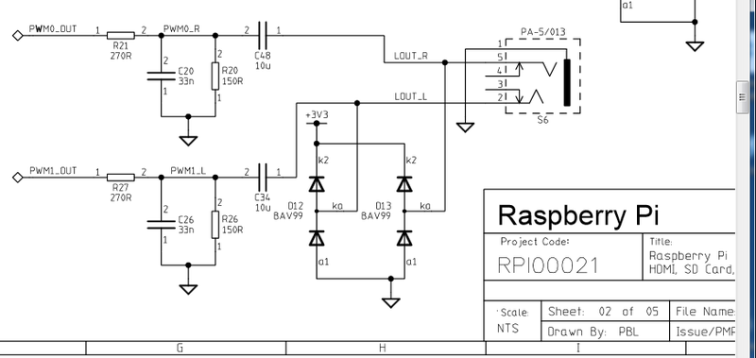
If you don't mind getting a few 150 and 270 ohm resistors, and two each of about 33nF (also known as 0.033uF) and 10uF capacitors, you can basically recreate those two filters.
Now all you need is access to PWM0_OUT and PWM1_OUT, which are...on GPIO #40 and #45 and are not brought out on the Pi Zero. Tragedy? Give up? No! You can get to PWM0 on GPIO #18 (ALT5) and PWM1 on GPIO #13 (ALT0) or GPIO #19 (ALT5)
Simply adding the following line to your /boot/config.txt will reconfigure the pins at boot without any external software or services:
dtoverlay=pwm-2chan,pin=18,func=2,pin2=13,func2=4

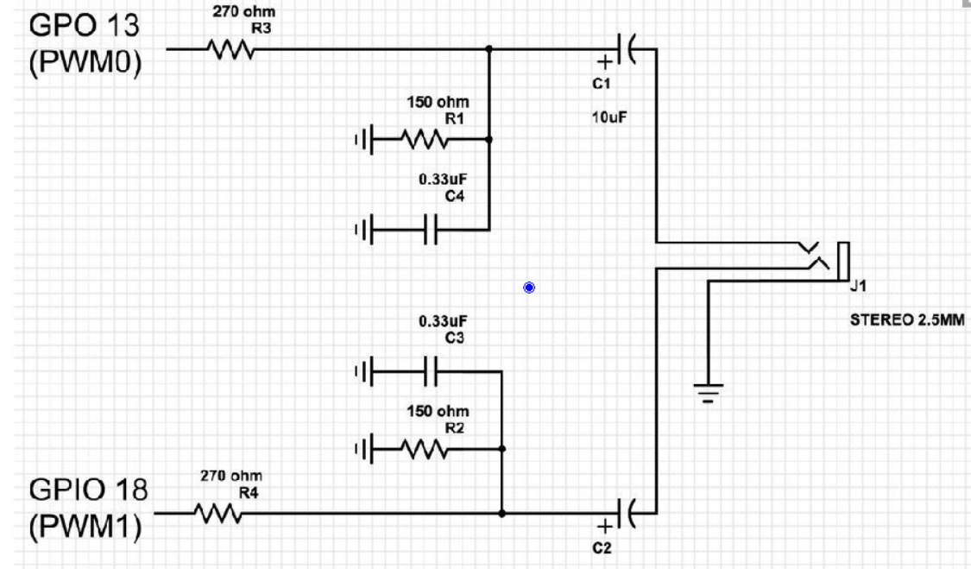

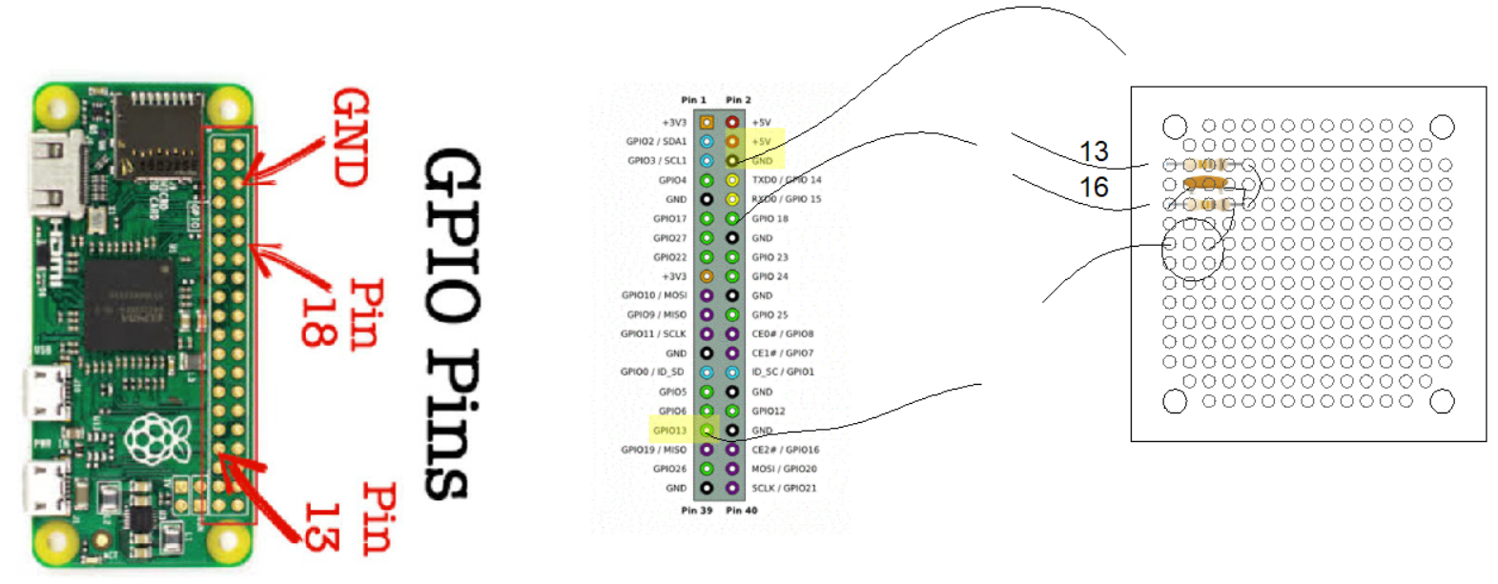
Appendix 4 Controlling the Rasp from a remote computer.

Putty FileZilla
Putty is an open source software that will allow you to open a text window on a remote computer. You must know the IP address of the Raspberry Pi (see below) and the user name and password. They are respectively pi and raspberry. Simply download putty and install on your computer
FileZilla is a free FTP client that needs to be installed on the remote computer.
After the FTP server software has been installed on the Raspberry Pi, the FTP client can be used to transfer files between the two systems. See the link below.
For these programs to load, you need to know the IP address of the Rasp Pi.
In a text window enter ifconfig
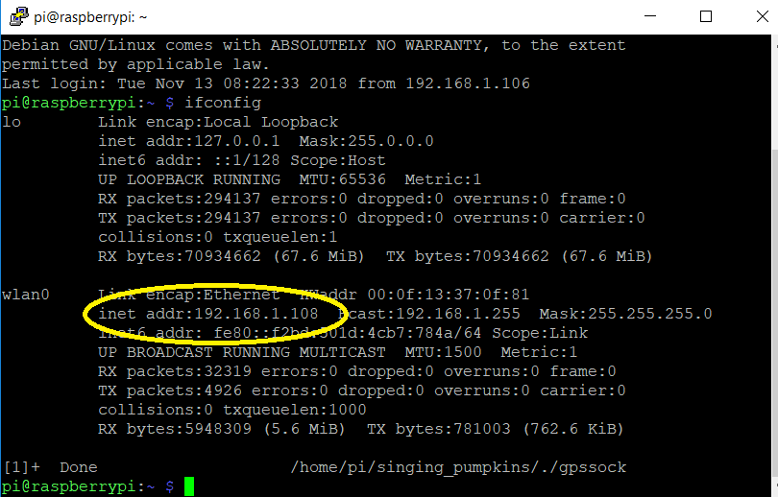
Install putty on the pc and you will be able to control the Rasp Pi from a text window on the pc.
The SSH must be enabled in the Rasp Pi. In a text widow, enter raspi-config…..
ftp or File Transfer Protocol. This will allow for moving files from the Rasp Pi to and from a windows system. An ftp server is installed on the Rasp Pi and an ftp client is installed on the PC. FileZilla works well.
See this link: https://howtoraspberrypi.com/setup-ftp-server-raspberry-pi/ for details on the installation of the ftp server on the Rasp Pi.
In a text window enter sudo apt install proftpd.
Appendix 5 GUI Control of the Raspberry Pi from a remote computer.

Real VNC Viewer
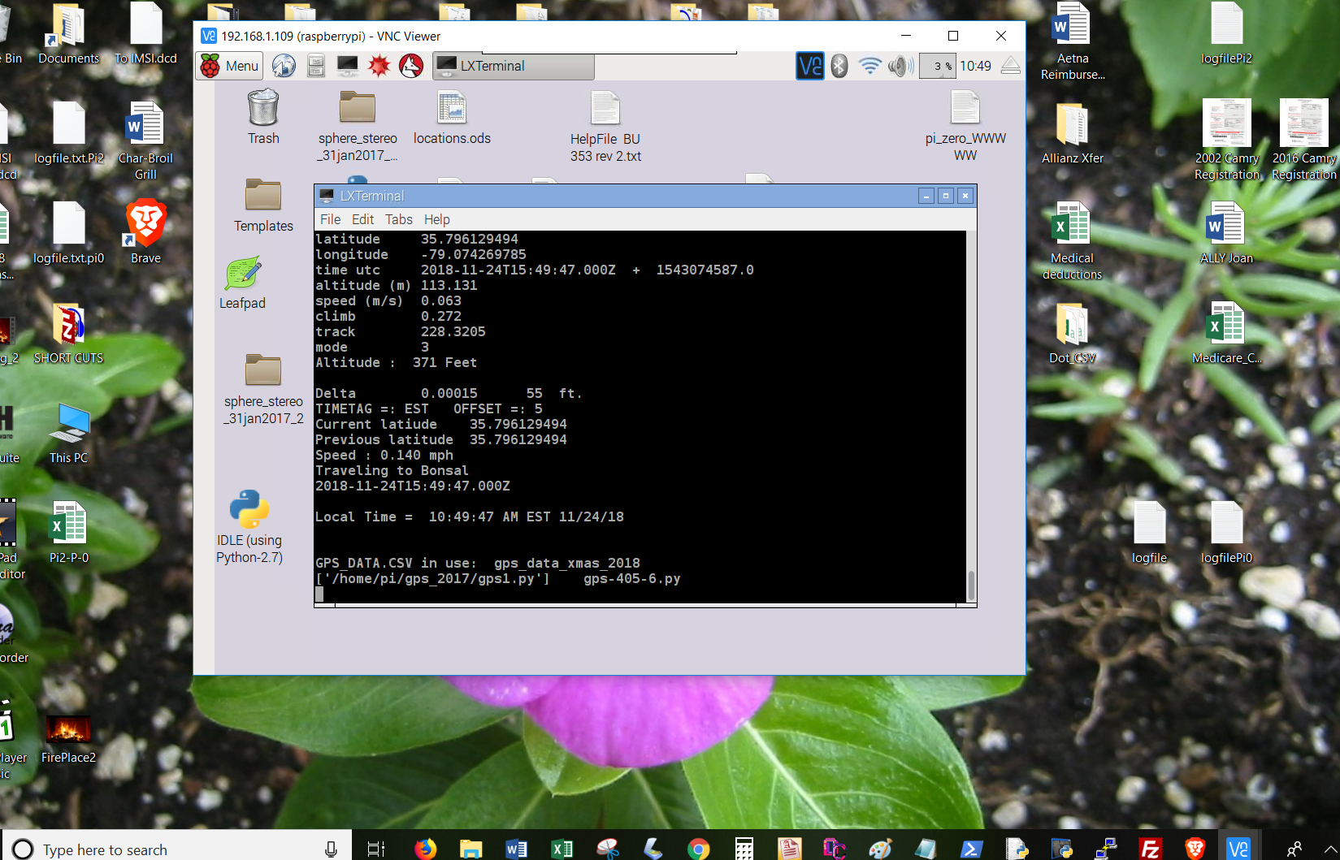
Detailed installation:
https://www.raspberrypi.org/documentation/remote-access/vnc/README.md
Run sudo apt-get update
Run sudo apt-get install realvnc-vnc-server realvnc-vnc-viewer
Run sudo raspi-config
After the install was completed, I ran raspi-config but could not find VNC!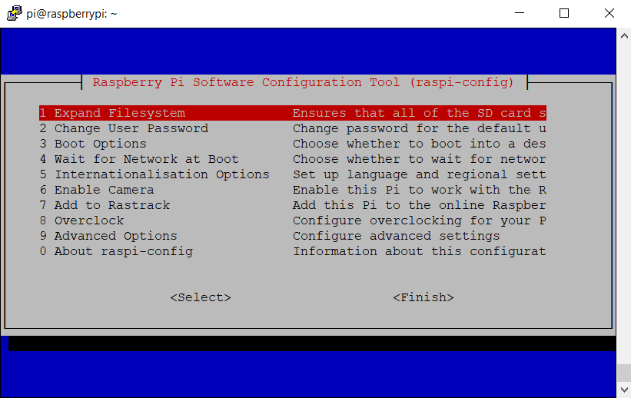
Select Advanced options
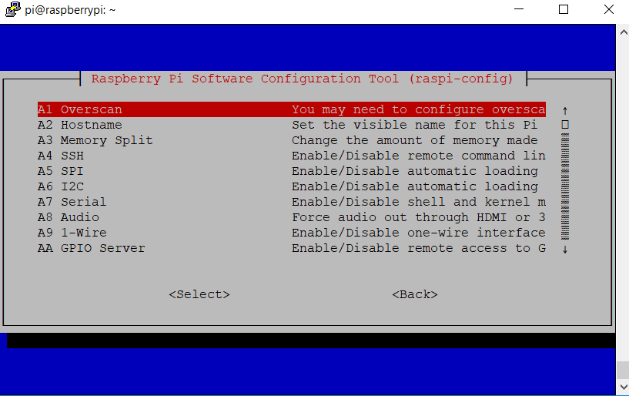
Use down arrow to scroll down and show additional options, to A0 Update. It is below the last item shown. Select AO Update. This will take several minutes to complete. It will then display:
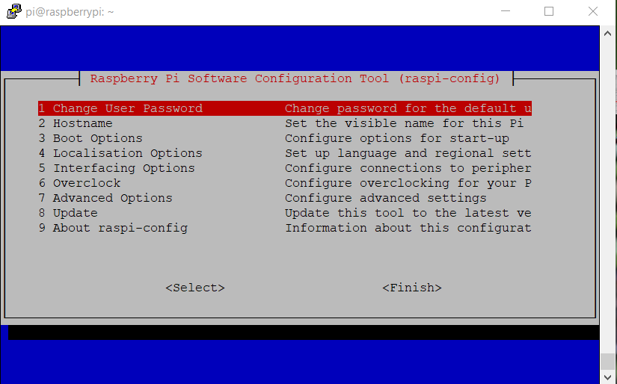
Now you can select Interfacing Options.
Select VNC and enable it.
Select finish.
Reboot the Rasp Pi and you will see:
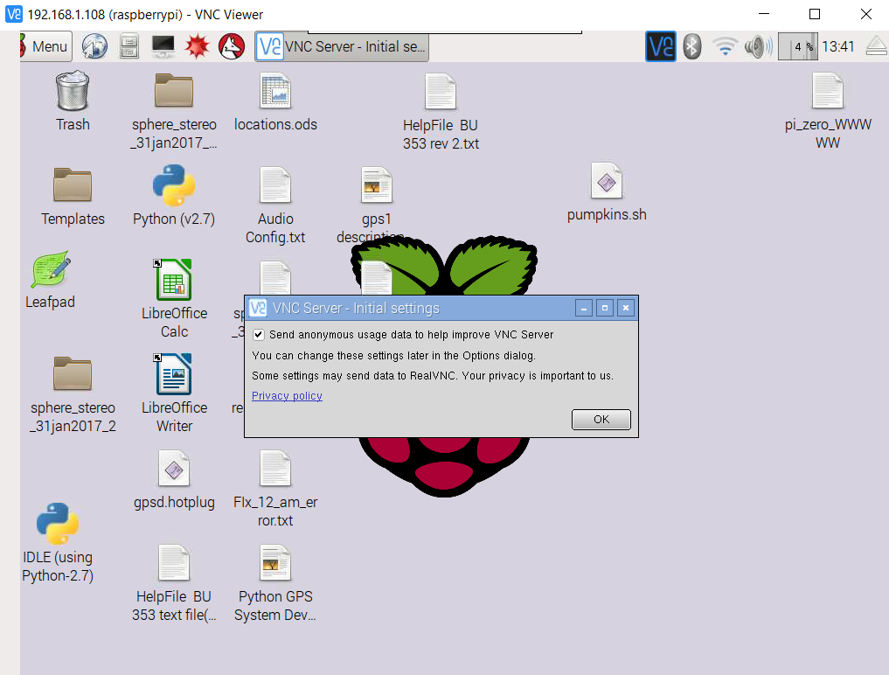
If you have RealVNC viewer on the controlling unit, it will connect!
Appendix 6 Setting Static IP Address
Works on Pi-Zero. NOT on Pi-3:
https://www.raspberrypi.org/learning/networking-lessons/rpi-static-ip-address/

If the desired static IP address of the raspberry pi is 192.168.1.201,
Add the following at the bottom of the /etc/dchpcd.conf file:
interface eth0

static ip_address=192.168.0.201/24
static routers=192.168.0.1
static domain_name_servers=192.168.0.1

interface wlan0

static ip_address=192.168.0.201/24
static routers=192.168.0.1
static domain_name_servers=192.168.0.1

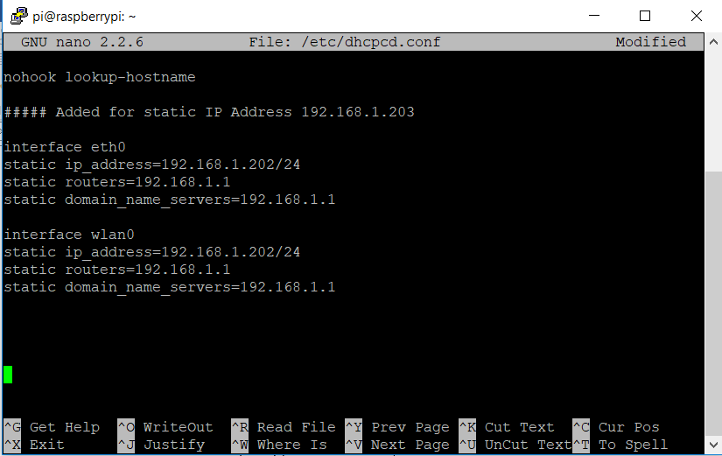

Appendix 7. Stopping the audio clip gps-406-6-1.py

There is a problem if the audio clip is longer than the time between locations. If this is the case, the clip will continue to play and the next clip will be skipped.
In the current system, the programs runs until it finds a location that matches one in the gps_data.csv file. It then halts the program and plays the clip. When the clip is finished, the program continues to run until it finds another location. If the audio clip is long and is playing while another location is past, the system will skip that location. By using a thread to play the audio clip, the system continues to run while the thread plays the audio clip. It can detect the next location and stop the clip using the killall function. The current location’s clip can then be played.

To solve this problem, a thread was added ( play_clip() )to play the audio clip.
def play_clip():
print'Beginning Thread play_clip'
os.system(xxx %sound)

When a new location is detected, the command :
os.system('killall omxplayer.bin')
is issued to stop omxplayer, if it is still running.

Then the command:
threading.Thread(target=play_clip).start()
Is issued to play the next clip

There is of course another problem. There are place holder silent audio clips in the gps-data.csv file. The name of these clips is silent_0001.wav
The program will look to see if the audio clip starts with sile . If it find this it skips stopping the playback. Below are the 4 lines of code that inhibit the thread when a silent file is detected
if files[0:4] <>"sile":
os.system('killall omxplayer.bin') #stops playing audio clip
if files[0:4] <>"sile":
threading.Thread(target=play_clip).start() #Plays clip througj threas
Below is the segment of the code that plays the audio clips at a specific latitude

file = open('/home/pi/gps_2017/logfile.txt','a')
for x in range(0,len(locs)):
if abs(lats[x] -latt) < delta:
#os.system('killall omxplayer.bin') #stops playing audio clip
playing_clip = 0 # Stops extra flashing
time.sleep(.5)
folder = '/home/pi/gps_2017/audio_tracks/'
files = mp3s_nb[x]
gain[x] = nb_gain[x]
if direction == 's':
files = mp3s_sb[x]
gain[x] = sb_gain[x]
sound = folder +files #
print x, files, gain[x]
###xxx = 'omxplayer --vol '+ gain[x] +' %s'
xxx = 'omxplayer -o local --vol '+ gain[x] +' %s'
if files[0:4] <>"sile":
os.system('killall omxplayer.bin') #stops playing audio clip
if files[0:4] <>"sile":
threading.Thread(target=play_clip).start() #Plays clip througj threas #os.system(xxx %sound) # used to lay the clip
lats[x] =lats[x] + 10 # takes the last played file out of list
file.write('\n' + str(x)+',') # Tne number of the location list
file.write (str(gpsd.fix.speed *2.236)[0:5]+' mph' + ' ' + direction +',')
file.write (str(gpsd.fix.track)+',')
file.write(EDST(gpsd.utc)+',')
file.write(' '+files +',') #the audio file name
file.write (gain[x]+',')
file.write(' '+locs[x]+ ',') #the location name
file.write(' '+str(gpsd.fix.latitude)+',')
file.write(' '+str(version)+'\n')
#lats[x] =lats[x] + 10 # takes the last played file out of list
last = x #### The last location's lats to reset it
x = x+1
time.sleep(1)
file.close()
lattold = latt

Appendix 8: Building the GPS system on the Raspberry Pi SD card
1- Copy NOOBS to SD card
Use a 16 gig type 10 SD chip.
Format the SD chip with SDFormatter
Download the latest NOOBS zip file.
Extract the zip file and copy the files to the SD memory card.
2- Boot Rasp Pi Select only Raspian
3- Install gps software
Do not connect the gps receiver
At the command line enter:
sudo apt-get install python gpsd gpsd-clients
The software will install.
Enter “Y” when promted
- Install mplayer software
At the command line:
sudo apt-get install mplayer
The software will install.

Copy the gps_2017 folder containing the operating program from a flash drive to the /home/pi directory

- Copy the gps_2017 folder containing the operating program from a flash drive to the /home/pi directory
Instructions to create the gpssock file.
This file should already be in the gps_2017 folder

Create the gpssock file in the gps_2017 folder
This file contains three lines:
either
sudo killall gpsd
sudo gpsd /dev/ttyUSB0 -F /var/run/gpsd.sock
sudo service ntp restart
or
sudo systemctl stop gpsd.socket
sudo systemclt disable gpsd.socket
sudo gpsd /dev/ttyUSB0 -F /var/run/gpsd.sock
Make it executable:
chmod +x gpssock
5-Install the GPS receiver
6- Run the gpssock file
At the command line, enter:
./gpssock
The . / is the command to run an executable file.

7- Run the trest program. At the command lineenter::
cgps -s
You should see the gps data
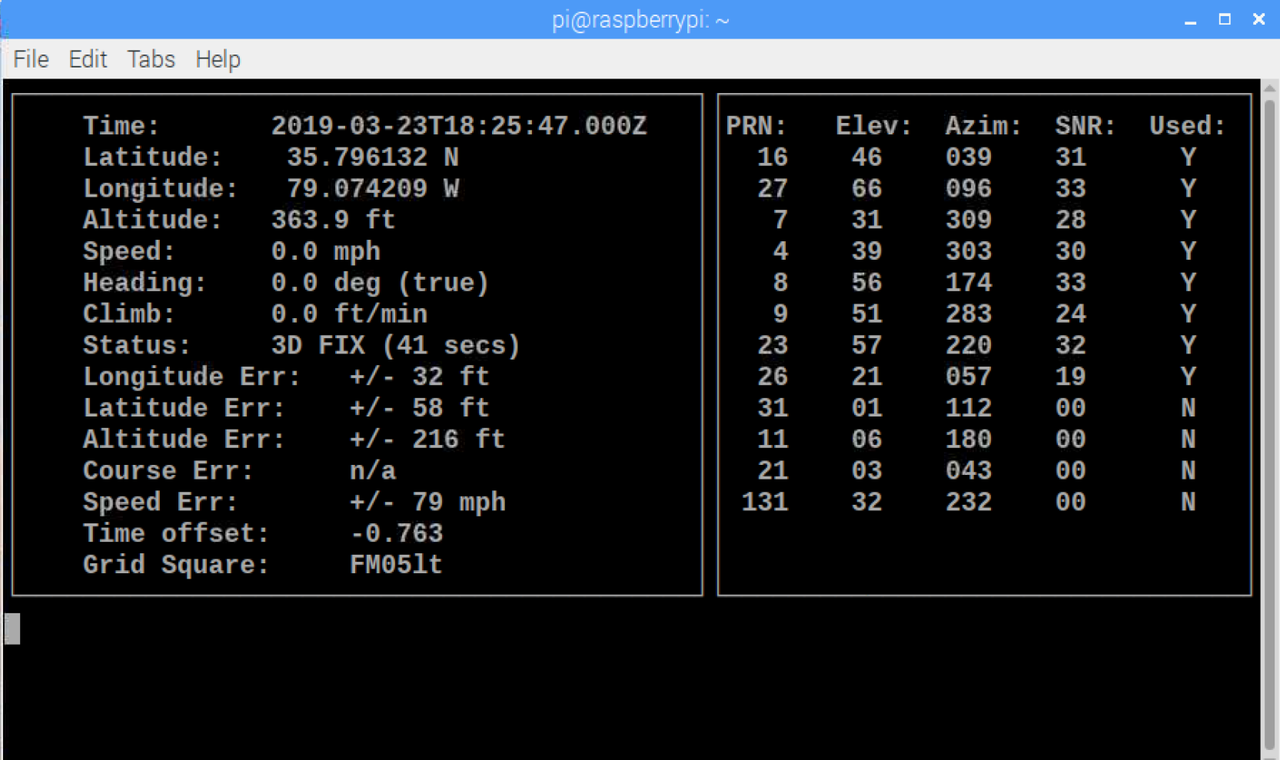
7 Add the line /home/pi/gps_2017/./gpssock & at the bottom of the /etc/profile file.
NOTE: The apersand (&) character is important.

This file is needed otherwise the gps receiver will not communicate with the Raspberry Pi. The exact reason for this is unclear.

7-a Alterative to the above, add the line:
os.system('./gpssock') (Added on gps_407-2-2-1-1)
This restarts the gps software without changing the profile file.
The downside to this is that the cgps -s program will not run until gps1.py is run.

- Install mplayer. This program is needed to play the background music track. (Added on gps_407-1)
At the command prompt, enter: sudo apt-get install mplayer. It may take 10 minutes to load.

9- Launch the GPS program
At the command line enter:
sudo python /home/pi/gps_2017/gps1.py

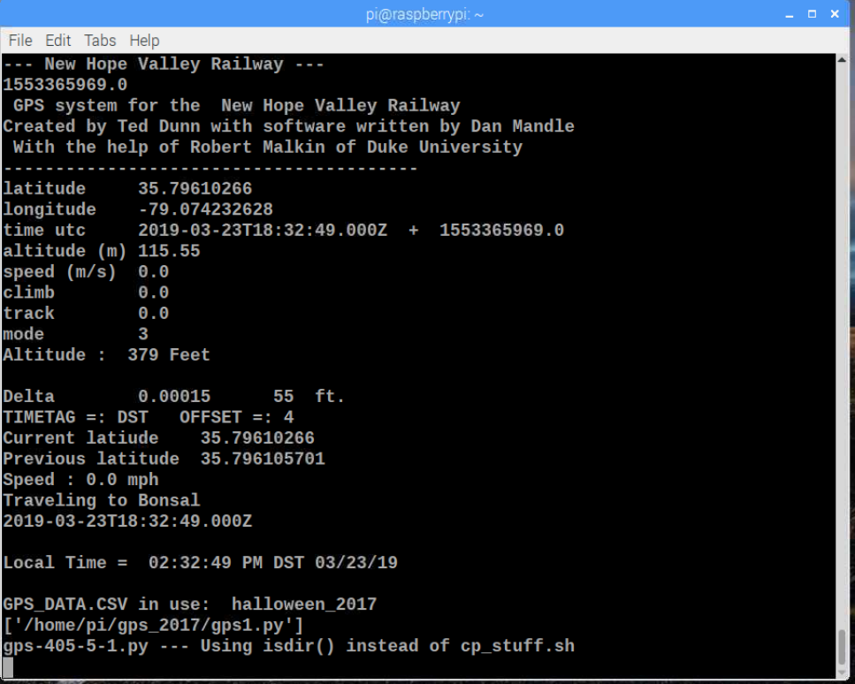

9- Setup to Auto start on power up
In order to have the system run automatically when power is applied the file: .desktop must be in the folder /home/pi/.config/autostart.
Create the autostart folder in the .config directory
Create the .desktop file in the autostart directory
Here are the three lines in the .desktop file:

Revised 3/23/19 for NOOBS 3.0
[Desktop Entry]
Type = Application
Exec = lxterminal -e sudo python /home/pi/gps_2017/gps1.py

The .config folder exists in the /home/pi folder. Create the autostart folder In the .config folder. Then create the .desktop file in the autostart folder.
Appendix 9 Run a Python program automatically on startup

This method will start a Python Program in a terminal widow.
The program is xyz.py and it is in the /home/pi/abc directory.

To do this, an autoexec.sh file is created in the startup directory, /home/pi. This is an executable linux shell file. It will run the Python file in the correct directory.

The name autoexec was chosen in remembrance of the unique DOS batch file, autoexec.bat. This file was automatically run on bootup in the DOS operating system. In Linux, the name of the file is not important.

To run this shell script on startup, it must be in the /home/pi/.config/autostart/.desktop file.

- Create the autostart directory in the /home/pi/.config directory.
  - Start from the /home/pi directory.
  - Change to the .config directory: cd .config
  - Create the autostart directory: mkdir autostart

- Create the .desktop file in the autostart directoty:
- Move to the autostart directory
- cd autostart
- Create the .desktop file
- sudo nano .desktop
  - Enter the follow 3 lines in the text editor:
    - [Desktop Entry]
Type = Application
Exec = lxterminal -e ./autoexec.sh (The ./ is used to run executable files.)
    - Press ctrl-o
    - Press Enter to save the file.
    - Pres ctrl-x to exit the text editor.

- Create the autoexec.sh file to run the xyz.py Python program in the /home/pi/abc directory.
  - Start in the /home/pi directory.
    - Create the autoexec.sh file: sudo nano autoexec.sh
    - Enter the following 2 lines:
cd abc
python xyz.py
    - Press ctrl-o
    - Press Enter to save the file.
    - Pres ctrl-x to exit the text editor.

  - Make the autoexec.sh file executable chmod +x autoexec.sh.

Note. The autoexec.sh file is not necessary. To run the file it could be placed in the last line of the .desktop file: Exec = lxterminal -e ./python home/pi/abc/xyz.py.
The advantage of the autoexec.sh file is that it makes it easier to change the autorun program.
1-The file to be edited is in the /home/pi directory instead of the /home/pi/.config/autostart directory.
2- Several autoexe.xx files can be save and easily be rename to the autoexec.sh file.

For example if one wishes to run a program name gps1.py which is located in the /home.pi/gps_2017 directory.
For example if one wishes to run a program name gps1.py which is located in the /home.pi/gps_2017 directory.
The autoexec.sh file in the /home/pi directory will have the following lines:
cd gps_2017
sudo python gps1.py

Appendix 10 MPLAYER keyboard controls
http://www.keyxl.com/aaa2fa5/302/MPlayer-keyboard-shortcuts.htm

MPlayer Keyboard Shortcuts

Keyboard control
<- and -> | Seek backward/forward 10 seconds.
up and down | Seek forward/backward 1 minute.
pgup and pgdown | Seek forward/backward 10 minutes.
[ and ] | Decrease/increase current playback speed by 10%.
{ and } | Halve/double current playback speed.
backspace | Reset playback speed to normal.
< and > | Go backward/forward in the playlist.
ENTER | Go forward in the playlist, even over the end.
HOME and END | next/previous playtree entry in the parent list
INS and DEL (ASX playlist only) | next/previous alternative source.
p / SPACE | Pause (pressing again unpauses).
. | Step forward. Pressing once will pause movie, every consecutive press will play one frame and then go into pause mode again (any other key unpauses).
q / ESC | Stop playing and quit.
+ and - | Adjust audio delay by +/- 0.1 seconds.
/ and * | Decrease/increase volume.
9 and 0 | Decrease/increase volume.
( and ) | Adjust audio balance in favor of left/right channel.
m | Mute sound.
_ (MPEG-TS and libavformat only) | Cycle through the available video tracks.
# (DVD, MPEG, Matroska, AVI and libavformat only) | Cycle through the available audio tracks.
TAB (MPEG-TS only) | Cycle through the available programs.
f | Toggle fullscreen (also see -fs).
T | Toggle stay-on-top (also see -ontop).
w and e | Decrease/increase pan-and-scan range.
o | Toggle OSD states: none / seek / seek + timer / seek + timer + total time.
d | Toggle frame dropping states: none / skip display / skip decoding (see -framedrop and -hardframedrop).
v | Toggle subtitle visibility.
j | Cycle through the available subtitles.
y and g | Step forward/backward in the subtitle list.
F | Toggle displaying forced subtitles .
a | Toggle subtitle alignment: top / middle / bottom.
x and z | Adjust subtitle delay by +/- 0.1 seconds.
r and t | Move subtitles up/down.
i (-edlout mode only) | Set start or end of an EDL skip and write it out to the given file.
s (-vf screenshot only) | Take a screenshot.
S (-vf screenshot only) | Start/stop taking screenshots.
I | Show filename on the OSD.
! and @ | Seek to the beginning of the previous/next chapter.
D (-vo xvmc, -vf yadif, -vf kerndeint only) | Activate/deactivate deinterlacer.
Hardware accelerated video output
1 and 2 | Adjust contrast.
3 and 4 | Adjust brightness.
5 and 6 | Adjust hue.
7 and 8 | Adjust saturation.
SDL Video Output Driver
c | Cycle through available fullscreen modes.
n | Restore original mode.
Multimedia Keyboard
PAUSE | Pause.
STOP | Stop playing and quit.
PREVIOUS and NEXT | Seek backward/forward 1 minute.
GUI Support (if compiled in)
ENTER | Start playing.
ESC | Stop playing.
l | Load file.
t | Load subtitle.
c | Open skin browser.
p | Open playlist.
r | Open preferences.
If TV or DVB support compiled
h and k | Select previous/next channel.
n | Change norm.
u | Change channel list.
Navigate menus (if DVNAV support)
keypad 8 | Select button up.
keypad 2 | Select button down.
keypad 4 | Select button left.
keypad 6 | Select button right.
keypad 5 | Return to main menu.
keypad 7 | Return to nearest menu (the order of preference is: chapter->title->root).
keypad ENTER | Confirm choice.
Teletext support (if compiled)
X | Switch teletext on/off.
Q and W | Go to next/prev teletext page.
mouse control
button 3 and button 4 | Seek backward/forward 1 minute.
button 5 and button 6 | Decrease/increase volume.
joystick control
left and right | Seek backward/forward 10 seconds.
up and down | Seek forward/backward 1 minute.
button 1 | Pause.
button 2 | Toggle OSD states: none / seek / seek + timer / seek + timer + total time.
button 3 and button 4 | Decrease/increase volume.

3.11. Software Volume adjustment
Some audio tracks are too quiet to be heard comfortably without amplification. This becomes a problem when your audio equipment cannot amplify the signal for you. The -softvol option directs MPlayer to use an internal mixer. You can then use the volume adjustment keys (by default 9 and 0) to reach much higher volume levels. Note that this does not bypass your sound card's mixer; MPlayer only amplifies the signal before sending it to your sound card. The following example is a good start:
mplayer quiet-file -softvol -softvol-max 300
The -softvol-max option specifies the maximum allowable output volume as a percentage of the original volume. For example, -softvol-max 200 would allow the volume to be adjusted up to twice its original level. It is safe to specify a large value with -softvol-max; the higher volume will not be used until you use the volume adjustment keys. The only disadvantage of a large value is that, since MPlayer adjusts volume by a percentage of the maximum, you will not have as precise control when using the volume adjustment keys. Use a lower value with -softvol-max and/or specify -volstep 1 if you need higher precision.
The -softvol option works by controlling the volume audio filter. If you want to play a file at a certain volume from the beginning you can specify volume manually:
mplayer quiet-file -af volume=10
This will play the file with a ten decibel gain. Be careful when using the volume filter - you could easily hurt your ears if you use too high a value. Start low and work your way up gradually until you get a feel for how much adjustment is required. Also, if you specify excessively high values, volume may need to clip the signal to avoid sending your sound card data that is outside the allowable range; this will result in distorted audio.

Added the ability to play a background audio track.
The track must be in the /home/pi/gps_2017/audio_tracks folder
To adjust the sound level, a keyboard must be connected.
Increase volume 0 key
Decrease volume 9 key
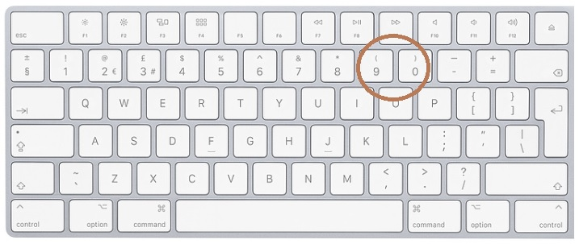

To play a background audio track, enter the data on the next to the last row. Enter the name of the track in column 4, the gain in column 5 and the number of times the track needs to be repeated in column 7.
Column 1 Column 2 Column 3 Column 4 Column 5 Column 6 Column 7
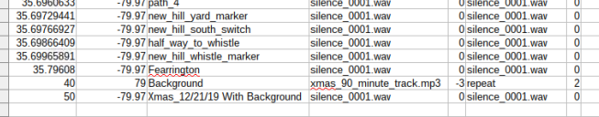
The last two lines in the gps_data.csv file are unique. The background audio track should be entered in the next to last line. The latitude of the bottom line should be set to 50 and the line above should be set to 40
Appendix 11 Find Daylight Savings Time dst(gpsd.utc) 4/28/2020
This python function, dst(utc), calculates the start date of Daylight savings time and the start date of Eastern standard time, for the date entered.
DST begins on the second Sunday in March and Ends on the first Sunday in November.
Today’s date is entered as a string in the format of yyyy-mm-dd.
The year, month and date are extracted and assigned to the variable tday.
The algorithm to find the start and end date of DST is as follows:
Find the number of the day of January first jan1=date(y,1,1) of the current year.
Find the day of the week for March 1.
Find the date of the second Sunday.
Find the number of the day for the second Sunday in March, DST start.
Find the day of the week for November 1.
Find the date of the first Sunday.
Find the number of the day for the first Sunday in November, EST start.
If the number of the day of today falls within DST start and EST start, today is on DST.
Otherwise, today is on EST

See Appendix 11-1 for all of the options of when DST starts and when EST starts.

The function imports the date functions from the standard library.
In Linux each day is assigned a number beginning on January 1, 1970
The number of the January 1 is assigned the variable jan1.
jan1 = date(yr,1,1)
It generates three dictionaries. The dst{} dictionary and the est{} dictionaly contain the offset of the first day of the month to the start of DST in March and the start of EST in November. See Appendix 1.
The dow{} dictionary shows the days of the week based on the numeric value from datetime. 0 is Sunday and 6 is Saturday.
The current date gpsd.utc is in the format of yyyy-mm-dd.
The yr, mon, and da variables are extracted from gpsd.utc.
yr = int(gpsd.utc)[0:4])
As an example, if gpsd = 2020-03-17, yr =2020
mon = int(gpsd.utc)[5:7])
da = int((gpsd[8:10])

Today is the variable tday.
tday = date(yr,min,da)
Today’s day of the week is dayofweek

The number for the day of January 1 of the year above is assigned to the variable jan1.
Jan1 = date(yr,1,1)
The day of the week of March 1, of the year above is assigned to the variable mar1.
mar1 = datetime.date(yr, 3, 1).weekday() # days 0-6
Similarly, for November 1.

From the dstr{} and est{} dictionaries the starting dates for daylight savings time and eastern standard time are the variables dst_start and est_start.
dst_start = dst.get(mar1) # This is the offset from Mar 1
est_start = est.get(nov1)

The number of the starting dates for daylight savings time and eastern standard times are:
start_dst= int((date(yr,3,dst_start)-jan1).days)
start_est = int((date(yr,11,est_start)-jan1).days)

Finally the timetag, either DST or EST is determined by:
if ttday-start_dst <0 or start_est - ttday <=0:
tag= 'EST'
else:
tag ='DST'
print 'Our time zone is on ',tag
timetag = tag
return (timetag)

An interesting observation regarding calendars is that March 1 and November 1, always occur on the same day of the week, regardless of the year.
Listing of dst(x)
def dst(utc):
####
###Finds the start of EST and DST from today's date
import datetime
from datetime import date

dst = {0:14,1:13,2:12,3:11,4:10,5:9,6:8} # off-set from Mar 1 to start of DST
est = {0:7,1:6,2:5,3:4,4:3,5:2,6:1} # off_set from Nov 1 to start of EST
dow = {0:'Monday',1:'Tuesday',2:'Wednesday',3:'Thursday',4:'Friday',5:'Saturday',6:'Sunday'}

xxx = gpsd.ut
yr = int(xxx[0:4])
mon = int(xxx[5:7])
da = int(xxx[8:10])
tday =date(yr,mon,da)

dayofweek = datetime.date(yr, mon, da).strftime("%A")

# find Jan 1 of year
jan1 = date(yr,1,1)

#find mar1
mar1 = datetime.date(yr, 3, 1).weekday()# days 0-6
nov1 = datetime.date(yr, 11,1).weekday()
print 'March 1 is on a :', dow.get(mar1)
print 'November 1 is on a :', dow.get(nov1)
dst_start = dst.get(mar1) # This is the offset from Mar 1
est_start = est.get(nov1)

print 'Today is :',xxx
print 'Today is ',dayofweek,' ',tday
print 'Daylight savings time starts on Sunday March' , dst.get(mar1),'th in ',yr
print 'Estern Standard time starts on Sunday November',est.get(nov1),'th in ',yr

print xxx
yr= int(xxx[0:4])
mon = int(xxx[5:7])
da = int(xxx[8:10])
tday =date(yr,mon,da)
dayofweek = datetime.date(yr, mon, da).strftime("%A")

# find Jan 1 of year
jan1 = date(yr,1,1)

#find mar1
mar1 = datetime.date(yr, 3, 1).weekday()# days 0-6
nov1 = datetime.date(yr, 11,1).weekday()
print 'March 1 is on a :', dow.get(mar1)
print 'November 1 is on a :', dow.get(nov1)
dst_start = dst.get(mar1) # This is the offset from Mar 1
est_start = est.get(nov1)

print 'Today is :',xxx
print 'Today is ',dayofweek,' ',tday
print 'Daylight savings time starts on Sunday March' , dst.get(mar1),'th in ',yr
print 'Estern Standard time starts on Sunday November',est.get(nov1),'th in ',yr
ttday =int((tday-jan1).days) # Number of days between today and 1/1
print dst_start
print est_start
print 'Number of days from Jan 1 to today ;',ttday
print 'tday: ',tday
print date(yr,3,dst_start)
print date(yr,11,est_start)
start_dst= int((date(yr,3,dst_start)-jan1).days)
start_est = int((date(yr,11,est_start)-jan1).days)

print start_dst
print start_est

if ttday-start_dst <0 or start_est - ttday <=0:
tag= 'EST'
else:
tag ='DST'
print 'Our time zone is on ',tag
timetag = tag
return (timetag)

Appendix 11-1
 |  | The start of Daylight Savings Time
 |  | is the second Sunday in March
 |  |  |  | Sun | Mon |  | Tue |  | Wed |  | Thu |  | Fri |  | Sat
 | Python Day Number |  |  | 6 | 0 |  | 1 |  | 2 |  | 3 |  | 4 |  | 5
 | If March 1 is Mon |  |  |  | 1 |  | 2 |  | 3 |  | 4 |  | 5 |  | 6
 |  |  |  | 7 | 8 |  | 9 |  | 10 |  | 11 |  | 12 |  | 13
 |  | DST starts |  | 14
 | If March 1 is Tue |  |  |  |  |  | 1 |  | 2 |  | 3 |  | 4 |  | 5
 |  |  |  | 6 | 7 |  | 8 |  | 9 |  | 10 |  | 11 |  | 12
 |  | DST starts |  | 13 | 14
 | If March 1 is Wed |  |  |  |  |  |  |  | 1 |  | 2 |  | 3 |  | 4
 |  |  |  | 5 | 6 |  | 7 |  | 8 |  | 9 |  | 10 |  | 11
 |  | DST starts |  | 12 | 13 |  | 14
 | If March 1 is Thu |  |  |  |  |  |  |  |  |  | 1 |  | 2 |  | 3
 |  |  |  | 4 | 5 |  | 6 |  | 7 |  | 8 |  | 9 |  | 10
 |  | DST starts |  | 11 | 12 |  | 13 |  | 14
 | If March 1 is Fri |  |  |  |  |  |  |  |  |  |  |  | 1 |  | 2
 |  |  |  | 3 | 4 |  | 5 |  | 6 |  | 7 |  | 8 |  | 9
 |  | DST starts |  | 10
 | If March 1 is Sat |  |  |  |  |  |  |  |  |  |  |  |  |  | 1
 |  |  |  | 2 | 3 |  | 4 |  | 5 |  | 6 |  | 7 |  | 8
 |  | DST starts |  | 9
 | If March 1 is Sun |  |  | 1 | 2 |  | 3 |  | 4 |  | 5 |  | 6 |  | 7
 |  | DST starts |  | 8 | 9 |  | 10 |  | 11 |  | 12 |  | 13 |  | 14
 |  | The start of Eastern Standard Time
 |  | is the first Sunday in November
 |  |  |  | Sun | Mon |  | Tue |  | Wed |  | Thu |  | Fir |  | Sat
 | Python Day Number |  |  | 6 | 0 |  | 1 |  | 2 |  | 3 |  | 4 |  | 5
 | If Nov 1 is Mon |  |  |  | 1 |  | 2 |  | 3 |  | 4 |  | 5 |  | 6
 |  | EST starts |  | 7
 | If Nov 1 is Tue |  |  |  |  |  | 1 |  | 2 |  | 3 |  | 4 |  | 5
 |  | EST starts |  | 6 | 7
 | If Nov1 is Wed |  |  |  |  |  |  |  | 1 |  | 2 |  | 3 |  | 4
 |  | EST starts |  | 5 | 6 |  | 7
 | If Nov 1 is Thu |  |  |  |  |  |  |  |  |  | 1 |  | 2 |  | 3
 |  | EST starts |  | 4 | 5 |  | 6 |  | 7
 | If Nov 1 is Fri |  |  |  |  |  |  |  |  |  |  |  | 1 |  | 2
 |  | EST starts |  | 3 | 4 |  | 5 |  | 6 |  | 7
 | If Nov 1 is Sat | EST starts |  |  |  |  |  |  |  |  |  |  |  |  | 1
 |  |  |  | 2 | 3 |  | 4 |  | 5 |  | 6 |  | 7
 | If Nov 1 is Sun | EST starts |  | 1 | 2 |  | 3 |  | 4 |  | 5 |  | 6 |  | 7

Appendix 12 Emulate a key press in a Python script.
This technique is listed to vary the volume of the audio tracks based on the speed of the train.
Xdotool

This works for numbers and letters. Not for special characters!

The command line is:
xdotool key [enter key]
I first tested that it would work using p for pause in the program listed below.

I had one additional problem. It did not work for special characters. And I needed + and -, for omxplayer!

I tried using ascii codes for special characters.
If you type ctrl-shift u and then the ascii code from the command line it does work.

xdotool key clrl+shift u 2b

2b is the hex for 43, the ascii for +.

But there is no way to do this in a python script (that I could find).

I posted a message on stack overflow and they provided the solution:

xdotool key plus
and
xdtool key minus

And it works in a python script.

os.system('xdotool key minus')

Below is the python script to test the procedure

################################
## ascci for'p' is 112 base 10, 1110000 base 2, 70 in base 16
## ascci for'+' is 43 base 10, 101011 base 2, 2B in base 16
## ascci for'p' is 45 base 10, 1110000 base 2, 2D in base 16
## xdotool ctl+shift u 70 returns p
import os
from gps import *
from time import *
import time
import threading
a=1
########################################################################
#Creates a thread to play an audio Clip
def play_clip():
playing_clip = 1
os.system(xxx %sound)
###################################################################
xxx = 'omxplayer -o both --vol 0 %s'
sound ='tone.mp3'
threading.Thread(target=play_clip).start()
print 'starting tone'
time.sleep(5)
while a==1:
#os.system('echo -n "-" > /proc/$(pidof omxplayer.bin)/fd/0')
#os.system('echo - > omxplayer.bin' )
print"ttt"
time.sleep(1)
os.system('xdotool key minus')
time.sleep(1)
os.system('xdotool key plus')
Appendix 13. Play audio tracks before the train leaves the station.
gps-409-2.py 5/8/23
In the effort to automate the announcer on the train, we needed to make announcement before the train leaves the station. This information is in the EXEL workbook used to create the Dispatcher’s Reports, 2023_Trains.xlsm.
In this workbook, the worksheet 2023_Trains, shown below contains the departure times.

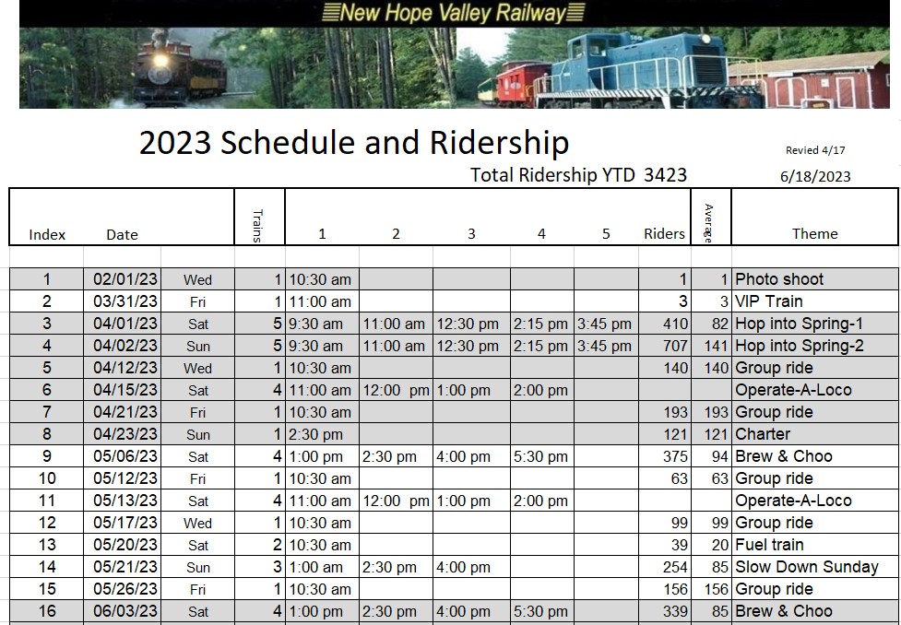

Copy this file without the header information to a new EXEL file.
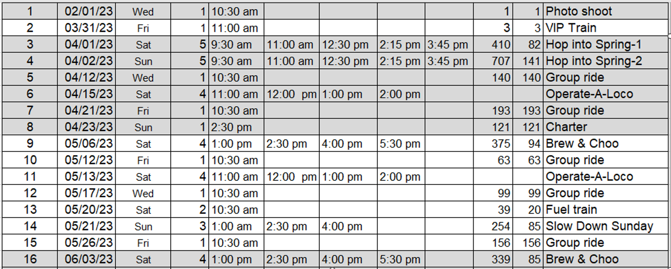
To insure the readability of the file:
Convert the date column from mm/dd/yyyy to m/d/yyyy.
Convert the am’s and pm’s to AMs and PMs.

The new EXEL file must then be saved as a .csv (comma separated value) file, with the name schedule.csv. This file needs to be in the working directory, /home/pi/gps_2017.

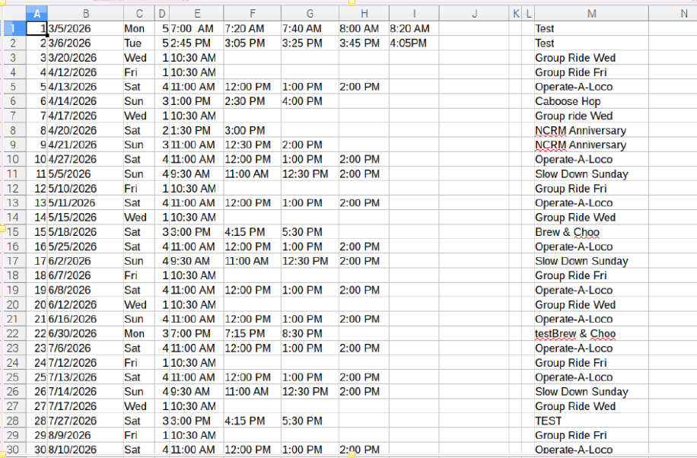
Example of the schedule.csv file

A python thread was created in the gps1.py program to perform this function: play_clips_before_departing.
The system was designed to play audio clips 15, 10, 5 and 1 minute before the train departs.
The files are:
1.mp3 is played 15 minutes before departure.
2.mp3 is played 10 minutes before departure.
3.mp3 is played 5 minutes before departure.
4.mp3 is played 1 minute before departure.

The play back volume is set by the variable pre_dep_vol .
The added row in the gps_data.csv file, adds a line with the latitude of 39 and sets the gain at 599. It is in the sixth column of third from the last row in the spreadsheet.
When the data from this file is imported, the pre_dep_vol is set to nb_gain[len(locs)-3].

Last few lines of the gps_data.csv file:
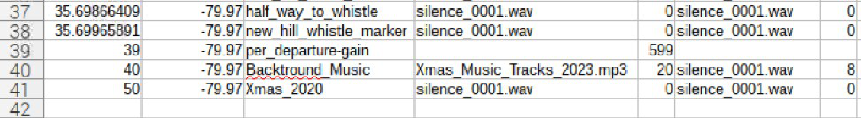

The build_file_names3.py was incorporated into the program and this is no longer needed.

A new Ctrl-c function was added to change the value of this variable. It is displayed on the screen along with the value that was found in the gps_data.csv file.
To change the pre_dep_vol level:
Press the Ctrl-c twice.
The LED will stop flashing and remain on.
Enter prevol.
Enter the desired pre_dep_vol level.
Note that the value entered is in milli-DB. -600 will reduce the value to half.

Screen capture setting level to 300:

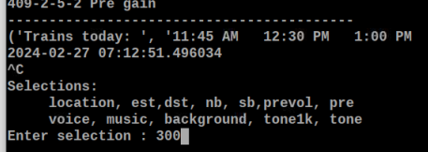

Last few lines of the display monitor:
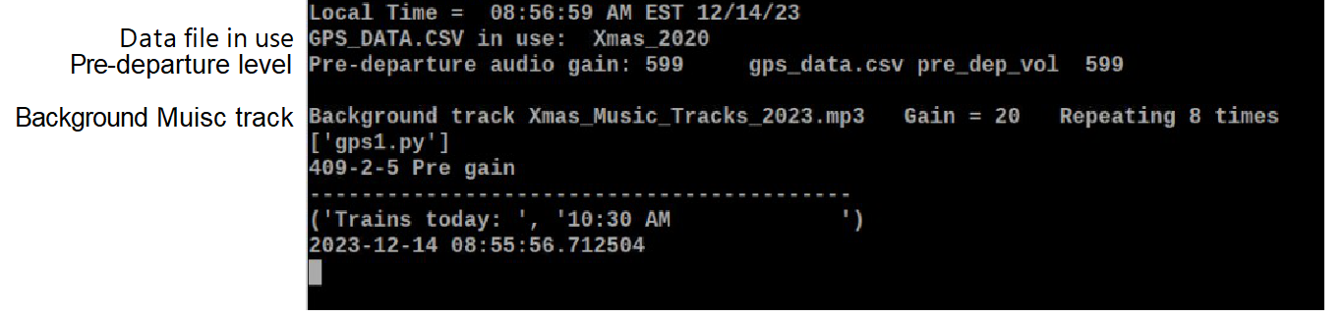

A script was created for each file and the texts were uploaded to a text to speech website:

https://speechify.com/text-to-speech-online/?landing_url=https%3A%2F%2Fspeechify.com%2Ftext-to-speech-online%2F

The audio files created were down loaded.
Audio files can also be edited with the open source and free software Audacity.

The following functions were used in this thread:
def convert24() This converts 12 hour time to 24 hour time
def convert_to_min() Converts hh:mm:ss to minutes from midnight
def con_min() Converts minutes to hh:mm in datetime. Note that this function was copied from an internet site.
Get schedule from Dispatcher’s Report 2023_Trains EXEL file.

This file is saved as a comma separated value file: schedule.csv.
The program then finds the schedule for today.
It then creates a list of the train times: t[] for the day. These train times are stings extracted from the .csv file.
If there are less than 5 trains in a day, the blank trains times in the t[] list are replaced with 2:00 AM times. This is a quick fix. Otherwise, the thread will crash if there are any empty times in the csv file.
The system stores the times for 5 trains and each train has 4 pre-departure announcements.
The advanced times for the announcement are 15, 10, 5 and 1 minute before the train departure times.
These advanced times are stored in a list: ad[].
To change these times, the python program will have to be edited.
This is the line of code that determines the time before departure
ad = [0,15,10,5,1] ## Advance times before departure
The audio files that will be played at the advanced times are named: 1.mp3, 2.mp3, 3.mp3 and 4.mp3. These file names are stored 5 times in the file_list[] list. These audio files must be in the /home/pi/gps_2017/audio_tracks folder.
They are stored 5 times so they can be accessed by the same dummy variable that detects the time of day.
The program then creates a list of all of the advanced announce times for the day and stores them in the Advanced Times list at[]. This is done in the nested for loop using the at.append command.
The at[] list is then sorted and it will now match up with the file_list[] discussed above.
The next part of the Thread uses a for loop to check if the time of day equals one of the advanced times in the at[] list:
ttt == at[x]
When this occurs, the system plays the corresponding audio file from the file_list[x+1].
It then records the time to the text file.
The program then sleeps for 61 seconds. Otherwise, the audio track would play again.

Appendix 14. Using VNC on Pi with a 3.5 inch display
When using a 3 ½ inch display on a Rasp pi, there are several issues that need to be addressed:
There is as problem using VNC to transfer files from the Rasp Pi to the pc.
There are additional problems when the FULLSCREEN mode is used.
There is an issue that you also have to deal with when transferring files to the Rasp Pi from a PC. The files can ONLY be sent from the PC to the Desktop folder on the Rasp Pi.
These issues are exhibited in the speedometer program. It consists of a Pi Zero driving a 3 ½ inch display. The graphics for the display were generated useing pygame which is set to FULLSCREEN mode.The program is set to run when power is applied to the Rasp Pi.

Here is the procedure:
Reboot the unit by powering down and then re-starting.
While the autoexec.sh file is launching the python script, stop the execution using Ctrl-c.
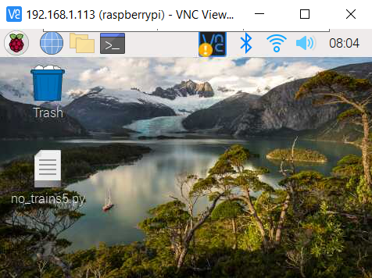 Fig 1
From this display on the tft screen and the VNC screen, if you click on the 
The display is will show as Fig 2.
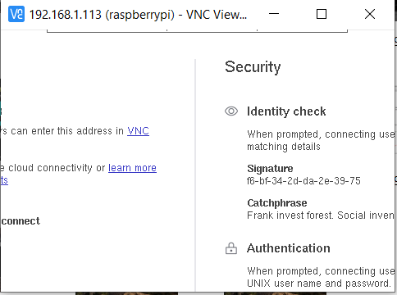 Fig 2
There is no way to exit this without rebooting!
So, do not do this.
The display needed will look like Fig 3.
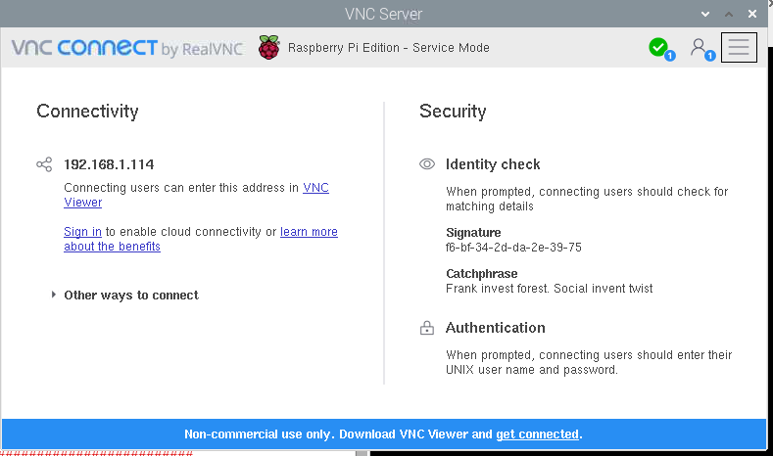 Fig 3

So then you can click on this icon  to transfer files an shown in Fig 4.
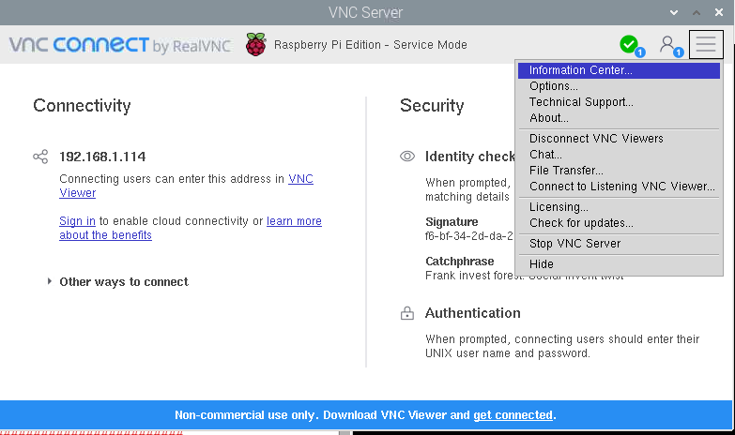 Fig 4

To get to this screen, you have to reboot again sending the display to the hdmi port, even though there is nothing connected to the hdmi port.
Reboot From a terminal window by entering ./hdmi. Then use Ctrl-c, to again, to kill python script that the autoexec.sh has launched. This will stop the FULLSCREEN mode. See Fig 5.
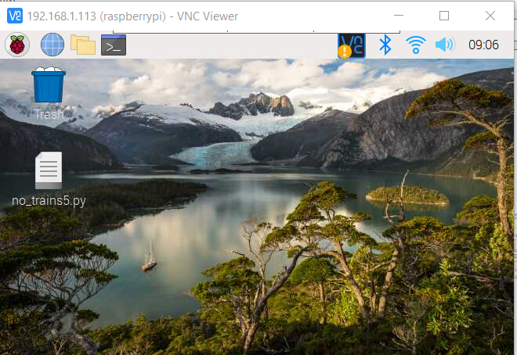 Fig 5 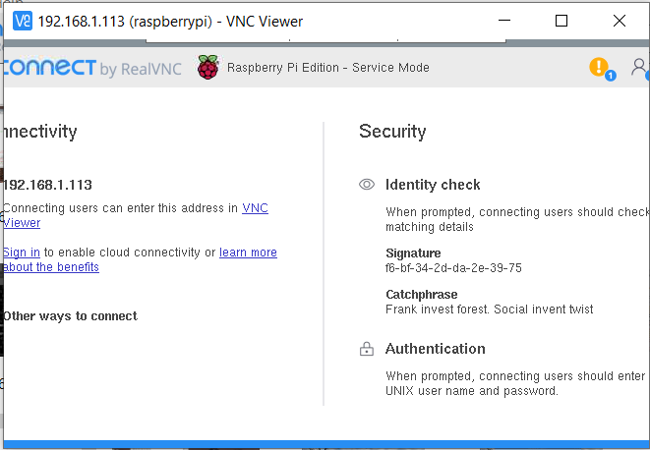 Fig 6
Now when click on , you will see the display Fig 6.
There is an area in Fig 7. that you can click on to move the frame and expose the necessary icon shown in Fig 8.
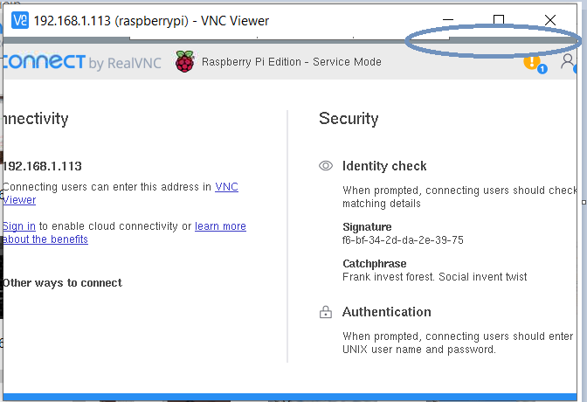 Fig 7 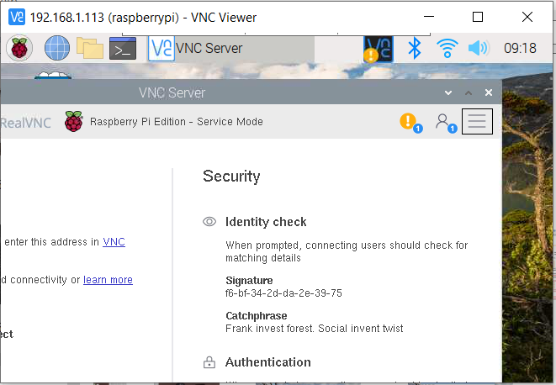 Fig 8

This is what we need to click on  to send files from the Rasp Pi to the VNC Viewer on the PC.
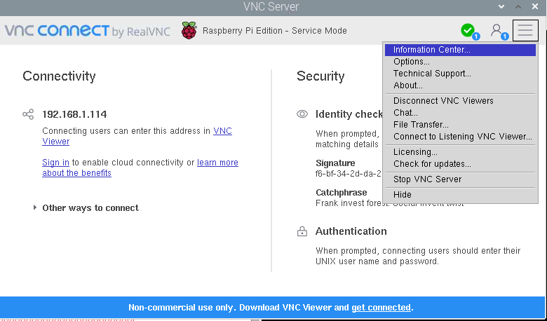 Fig 9.

To return to normal, reboot using ./tft from a terminal window.

Appendix 15 Format an SD card diskpart
General Causes for SD Card Won't Format
When a memory card runs into problems and needs to be formatted to function again, to a large extent, something goes wrong with the file system.
For example, only FAT32 SD card can be used on some specified devices; SD card file system suddenly turns raw, and Windows cannot recognize it; SD card does not show up as a mass storage device but unallocated space, etc.
However, it says formatting SD card will fix problems like these, but why did we fail to format SD card eventually? We arrived at some simple conclusions that may cause the issue of SD card won't format.
· SD card is write-protected so that Windows is not allowed to make changes to it;
· SD card is with bad sectors on it, so it becomes corrupted. Windows can't format corrupted SD card.
· Using the portable SD card storage media across multiple computers or card readers can be easily infected with a virus, it makes Windows hardly be able to format the card to eradicate the virus.
How to Fix SD Card Won't Format Error
So, what are the solutions for the error? How to format SD card that won't format? Altogether, we introduce two quick fixes that are supposed to solve the problem. When you're facing the similar case that a memory card won't format on a Windows PC or an Android phone device, feel no hesitate to troubleshoot the error using the suggested methods.
Method 1. Run Diskpart to Format SD Card That Won't Format
Step 1. Press Windows key and R key at the same time, type cmd in the Run boc36Tillisx, hit Enter to open the command prompt(cmd.exe).
Step 2. Type diskpart to run Diskpart Utility.diskpart
Step 3. Type list disk to list the drives on the computer.
Step 4. Type select disk 1 (The number should be replaced by the exact drive number of your SD card).
Step 5. Type clean to run the clean utility (this will wipe all data on the SD card so make sure you saved a copy or backup of the card data).
Step 6. Type create partition primary to create a new partition on the SD card.
Step 7. Type select partition 1 (it should be the newly created partition on step 6).
Step 8. Type active to make the partition active.
Step 9. Type format fs=ntfs （or format fs=fat32）to format the partition to the desired file system.
fat32 for Rasp Pi

Table of Contents
Appendix 1 Omxplayer commands
Appendix 2 USB_DISK boot routine
Appendix 3 Pi-Zero analog audio
Appendix 4 Controlling the Pi with PUTTY and FILEZILLA
Appendix 5 Controlling the Pi with VNC
Appendix 6 Setting static IP address
Appendix 7 Stopping an audio clip
Appendix 8 Building the GPS system on the SD card.
Appendix 9 Run a python program on boot up
Appendix 10 Mplayer commands
Appendix 11 Auto-correct for Daylight Savings Time
Appendix 12 Emulate a key press in a Python script.
Appendix 13 Play audio tracks before the train leaves the station.
Appendix 14 Using VNC with 3.5 inch display
Appendix 16 diskpart
Appendix 17 New Hill Yard audio

Appendix 17 New Hill audio 7/5/26
It was decided that we need to play audio messages for the passengers after the train has stopped in New Hill yard. The function play_New_Hill_files() was created for this purpose.
This will play three audio files.
The first one will start 120 seconds after the train stops. It is an arrival announcement.
The second audio clip will start 480 seconds after the stoppage to allow for the engine travel down the passing siding. It will be an introduction to the history of the New Hope Valley Railway.
The third audio track will start 600 seconds from the stoppage and will be a continuation of the history of the railway.
To activate this function an if statement was added to the main loop
##################################### Play New Hill audio files ########################
if latt > 35.698 and latt<35.7 and gpsd.fix.speed*2.236<3:
# Train is in New Hill and stopped and not past Fearrington
play_New_Hill_files()

##################################### END Play New Hill audio files ########################

The lat<35.7 was added allow the system to be tested at home.

In the program the audio files are nh_0.mp3, nh_1.mp3 and nl_2.mp3).

The track nh_0.mp3 is the arrival track. The track nh_1.mp3 is the history 2 track and the track nh_2.mp3 track is the history 2 track. This is hard coded into the gps1.py file.
The delays before playing the tracks are 120 sec, 480 sec and 600 sec. nhsl_0, nhsl_1 and nlsl_2.

The number of files, there names and the delays are coded into the program they are not, at this time, stored in the EXEL/.cav file.
The volume level is set to the pre departure files level. That is in the EXEL file and can be change using the ctrl-c functions.
A new ctrl-c option was added, nh, to play all three of these files:

print('Selections:')
print(' location, est,dst, nb, sb, prevol, pre')
print(' voice, music, background, tone1k, tone,nh ')
datapoint = raw_input('Enter selection : ')

To be done.

Change file names back to the descriptive file names with durations. Now they are nhsl_1.mp3 etc
Add a routine to display the time of the delays
Calculate delays from data in file names
Add a way to store delay times in the .csv file
Add the volume of the New Hill files to the .csv file.
Add prints to display that show New Hill countdown and which file is to be played

Revision log

7/17//26
gps-410-5-3 Add pre4 to the ctrl-c function to play the file 4.mp3
This was added to allow the operator to play the last pre-departure file if the train is delayed.
The latest image file is: c:\image_files\GPS_7-16-26-2.img.
The additional files needed are: gps-410-5-3.py.

7/5/26 The gps-410-5.py added a function that plays 3 audio tracks after the train has stopped at New Hill.
The files are: nh_0.mp3, nh_1.mp3 and nl_2.mp3).
See Appindex 17 for details.
Known errors:

Note: 12/1/24 When the HDMI port is connected, the mplayer directs the audio to this port only. When the port is not connected, the audio is directed to the analogue port.

With the implementation of Auto-Reboot feature in version 409-3-1 a new error was detected that is otherwise not a problem.
If there are no rides on today, the system picks up the schedule for the first ride day of the year. It will play the pre departure clips for that day.
Untested solution: ass a blank day to the beginning of the schedule.
Version gps-409-3-1-1.py 9/17/24
Cosmetic changes to Terminal display
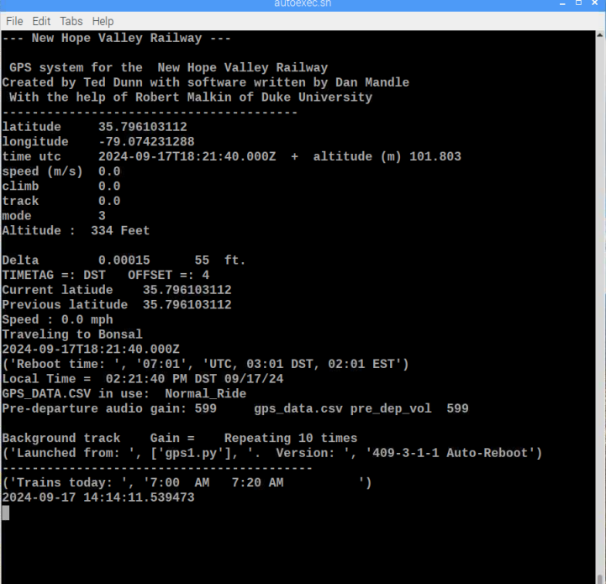

Version gps-409-3-1.py 9/16/24
In the earlier version the system would reboot at 01:01 PM in addition to 01:01 AM.
This version reboots at 07:01 utc. Or 03:01 AM DST, 02:01 AM EST.
This occurs only once a day.

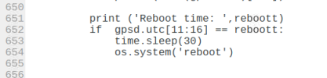

Version gps-409-3.py 9/16/24
The system was installed in caboose 302. A 25 watt solar panel was added to the roof. This panel will charge the Li-Ion battery. The system runs autonomously, but it must be rebooted each day to load the schedule file.
The variable reboott was added and set to the reboot time, 01:01 AM.
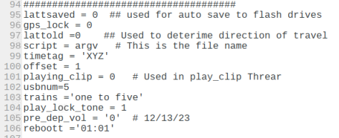
The if command was added at line 650 to cause the system to reboot.
The time.sleep(30) was added in case the system rebooted in less than a minute. Otherwise, it would reboot a second time.
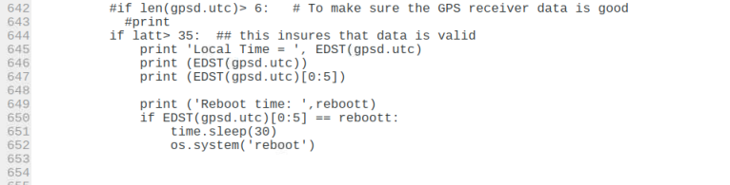

The reboott time was also added to the Terminal Display.
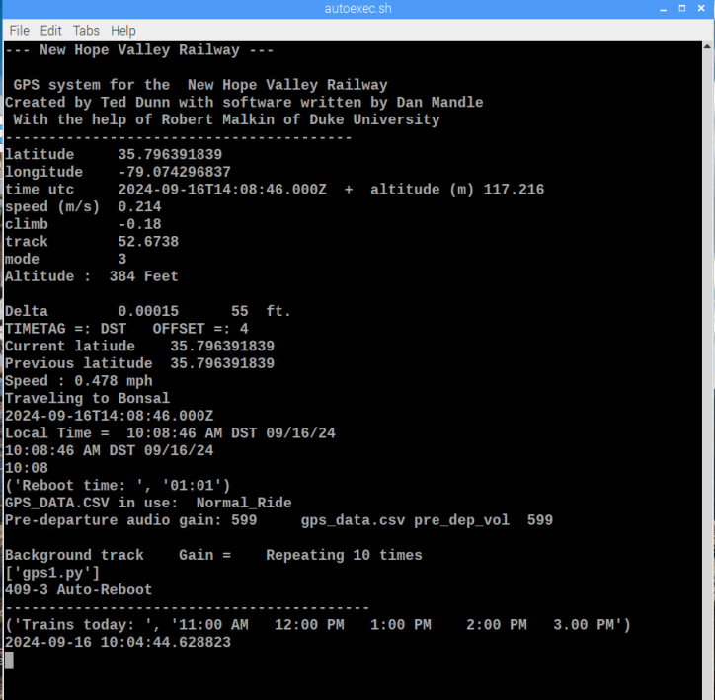
Revision 409-2-5-3 3/6/24
Fixed the problem. Now the Ctrl-c function for pervol works.
###############################################################
folder = '/home/pi/gps_2017/audio_tracks/'
#pre_dep_vol = '600'
#pre_dep_vol = nb_gain[len(locs) -3] ## 12/13/23
volume = pre_dep_vol # 2/26/24

files = file_list[x+1]
sound = folder +files

xxx = 'omxplayer -o local --vol '+ volume +' %s'
print xxx
os.system(xxx %sound)
…….
Revision 409-2-5-2 2/26/24
Fix error:
Added the line: to make the volume equal to the variable
volume = pre_dep_vol # 2/26/24
to make the volume equal to the variable
###############################################################
folder = '/home/pi/gps_2017/audio_tracks/'
pre_dep_vol = '600'
pre_dep_vol = nb_gain[len(locs) -3] ## 12/13/23
volume = pre_dep_vol # 2/26/24

files = file_list[x+1]
sound = folder +files

xxx = 'omxplayer -o local --vol '+ volume +' %s'
print xxx
os.system(xxx %sound)

Revision 409-2-5 12/13/23
Added variable pre_dep_vol which controls the volume level of the pre-departure audio tracks. This the default value of this variable extracted from the gps_data.csv file. This value can be changed using the ctrl-c function prevol.
The build_file names3.py was incorporated in to the program and is no longer needed. See Appendix 13 for details.

This version changed the audio output to both for the Raspberry Pi Zero.

Revision 7/24/2023
### Version 409-2-4 Fix error in Ctrl-c when GPS is not locked
If GPS is not locked and Ctrl-c is accessed, the system crashes.
This happens when the date and time of the Ctrl-c action is logged in the datafile.txt.
Changed From To
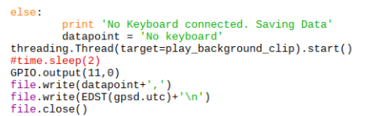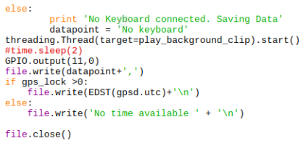

Revision 4/28/20 gps-407-3-2.py
The update uses the function dst(gpsd.utc) to determine the starting dates of DST and EST. This eliminates the need for the find_dst_import.py and read_data.txt files.
Revision 3/20/20 gps-407-3.py added auto EST-DST correction. This uses the find_dst_import.py routine to find the dates of DST and EST for that year. The file find_dst_import.py file was added the gps_2017 directory and the highlighted lines were added to make the gps-404-3.py file. When the GPS receiver has locked on to the satellites, the date information is written to the read_data.txt file. This data is read by the find_dst_import.py to determine the off_set. This is only performed once, since the gps_lock and check_timetag variables are set to 1.
if latt >35 and gps_lock == 0:
gps_lock = 1
print 'GPS Locked'
file = open('/home/pi/gps_2017/logfile.txt','a')
file.write(EDST(gpsd.utc) +' '+'GPS Receiver Locked \n')
file.write(' '+str(script))
file.close()
file = open('read_data.txt', 'w') # Saves time for find_dst_import
file.write(gpsd.utc)
file.close()

check_timetag = 1
from find_dst_import import tag
timetag = tag
if tag == "DST":
off_set = 4
else:
off_set = 5

The est_dst.txt file is not needed and was deleted from the gps_2017 directory
The highlighted lines were deleted since they were no longer needed:
else:
print 'NO DISK FOUND.'
file.write('NO DISK FOUND.'+'\n')
time.sleep(3)

###################################################################
################## Read offsett and timestamp from est_dst.txt
############### readtime.py
with open('/home/pi/gps_2017/est_dst.txt') as g:
content = g.readlines() # reads the data

y=str(content) # converts the data to a string

offset = int(y[2:3]) # strips the offset data
timetag= y[3:6] # strips the timetag data

g.close()
############################################################
from load_csv_data import*
def EDST(utc): # Strips time from gpsd.utc
timee=utc[11:19]
hr=utc[11:13]

See Appendix 11 for the details on finding the DST dates in the find_dst_import.py.

Revisions : 2/2/18 added autosave logfile to USB_DISK
The latest version is gps-404.py. This has the auto save of the logfile.txt to a flash drive with the name USB_DISK .
9/18/18 Version gps-405 removed the cp_stuff.sh file and included the features within the main program.
10/30/18 The latest version is 405-5
12/11/18 revised play.py Enter index number instead of file names . Requires the text_file_2_array.py file
Created playcsv.py to play the audio files in current gps_data.csv file, except the silence_0001.wav files.

1/16/19 Added the thread to play the audio clips
Added
########################################################################
#Creates a thread to play an audio Clip
def play_clip():
playing_clip = 1
os.system(xxx %sound)

Added:

file = open('/home/pi/gps_2017/logfile.txt','a')
for x in range(0,len(locs)):
if abs(lats[x] -latt) < delta:
#os.system('killall omxplayer.bin') #stops playing audio clip
playing_clip = 0 # Stops extra flashing
time.sleep(.5)
folder = '/home/pi/gps_2017/audio_tracks/'
files = mp3s_nb[x]
gain[x] = nb_gain[x]
if direction == 's':
files = mp3s_sb[x]
gain[x] = sb_gain[x]
sound = folder +files #
print x, files, gain[x]
###xxx = 'omxplayer --vol '+ gain[x] +' %s'
xxx = 'omxplayer -o local --vol '+ gain[x] +' %s'
if files <>"silence.0001.wav":
os.system('killall omxplayer.bin') #stops playing audio clip
if files <>"silence.0001.wav":
threading.Thread(target=play_clip).start() #Plays clip througj threas #os.system(xxx %sound) # used to lay the clip
lats[x] =lats[x] + 10 # takes the last played file out of list
file.write('\n' + str(x)+',') # Tne number of the location list

3/9/19 When the Raspberry Pi is powered by the switching regulator installed in the amplifier, it creates high frequency oscillations that show up as noise in the audio. To eliminate this interference, a 1:1 audio transformer was added between the output of the Raspberry Pi and the input of the amplifier.
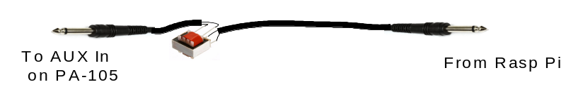
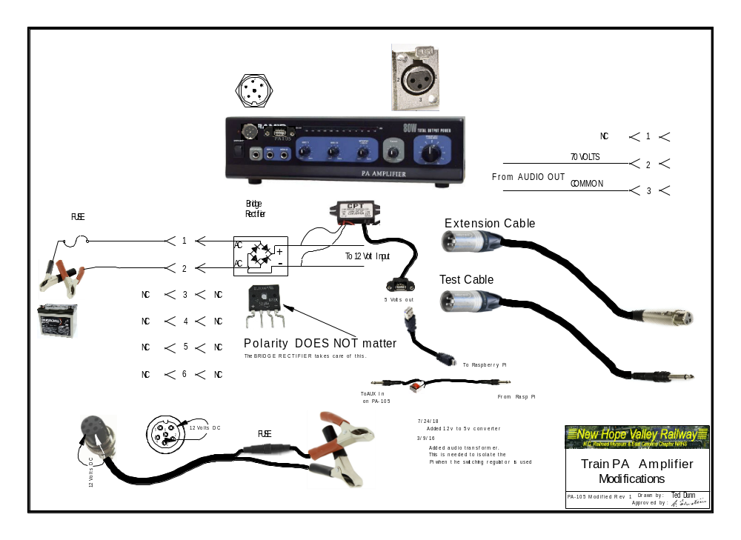

12/18/19
Added a background audio track to the system. Version gps-407-1.py.
Note: 12/1/24 When the HDMI port is connected, the mplayer directs the audio to this port only. When the port is not connected, the audio is directed to the analogue port.

A thread was added to play an audio track continuously
def play_background_clip():

os.system("mplayer /home/pi/gps_2017/audio_tracks/xmas_90_minute_track.mp3 -loop 10 -af volume=-20")
threading.Thread(target=play_background_clip).start()

Since we are using omxplayer for the individual audio tracks and we use the killall command to stop omxplayer, we are using mplayer to play the background music track. Note that is was necessary to use the absolute path for the location of the audio track. If we use the relative path, the system would not play the track on boot up.

