Singing pumpkins setup

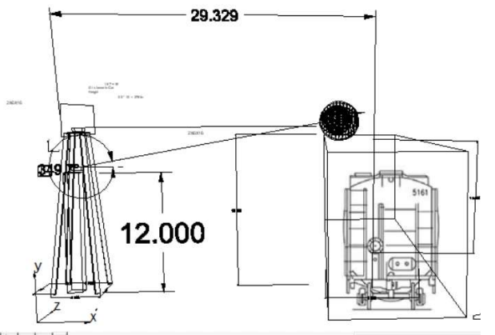

The singing pumpkins uses a video projector to display the singing pumpkins on three plastic pumpkins mounted on the platform on the roof of the Gift Shop box car.
The audio and video clips are played from a Raspberry Pi mini-computer installed next the projector.
The center of the stand needs to be 30 feet from the rail as shown above.
A 75 foot power cable needs to be run from to provide the power to the projector.
Before removing power to the system, use the projector remote to turn off the projector lamp and let the system run for 5 minutes to cool down the projector lamp.
The projector used is a Panasonic PT-F300U.
An audio cable from the receiver/amplifier must also be run to the top of the stand.
A flood light is needed to dimly illuminate the orang face of the pumpkins. Otherwise they are totally black.

A raspberry Pi -0 mini computer plays the 13 mp4 files continuously.
Parts required:
Raspberry Pi-0 computer.
SD card with mp4 files and python program installed
HDMI mini adapter
HDMI to VGA convertor with audio.
5 volt power supply
VGA cable
Audio cable to amplifier
Video projector
Remote Control
Power cord
Extension cord
Power strip
Fill lamp

The mp4 files were purchased from the website:
Singing Pumpkins Animations


A power cable needs to be run from the AC receptable on the north end of the gift shop car, routed up the ladder and flown over top the tripod tower.

An audio cable hanging on the roof of the gift shop car needs to be extended and run along with the power cable to the tripod tower and plugged into the audio output of the Raspberry Pi. This cable is connected to the VIDEO 2 input port of the amplifier.

A flood light is needed to provide fill light on the pumpkins. Without the flood light youi cannot see the pumpkins when it gets dark.
The audio amplifier is on a shelf in the gift shop. The wires for the audio input and the speaker outputs are routed through two holes drilled into the side of the gift carabove the door.

Note that, in 2024, if the power is applied to the system during the day and the projector lamp is off, it may not respond to turning on the lamp by either the inferred remote or the button on the front panel.
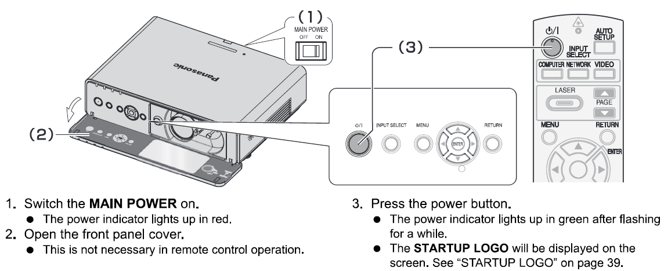

To revive the system, turn off the main power switch, wait 5 seconds and turn it back on.

Also note that the 12.5 mm audio connector plugged into the HDMI to VGA convertor can sometimes be intermittent.

